HandOut.3: Docker-Images-Containers-Volumes-Compose

All the commands are in RED should be tried out in sequence mentioned on CMD

ZUHA AQIB 26106 MAHNOOR ADEEL 26193

# Login to Docker:

Confirm that you have docker installed: docker –version

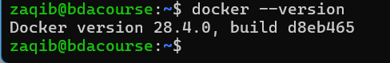

Login: docker login (you might be asked your credentials for hub.docker.com)

You will receive a success message “Login Succeeded”

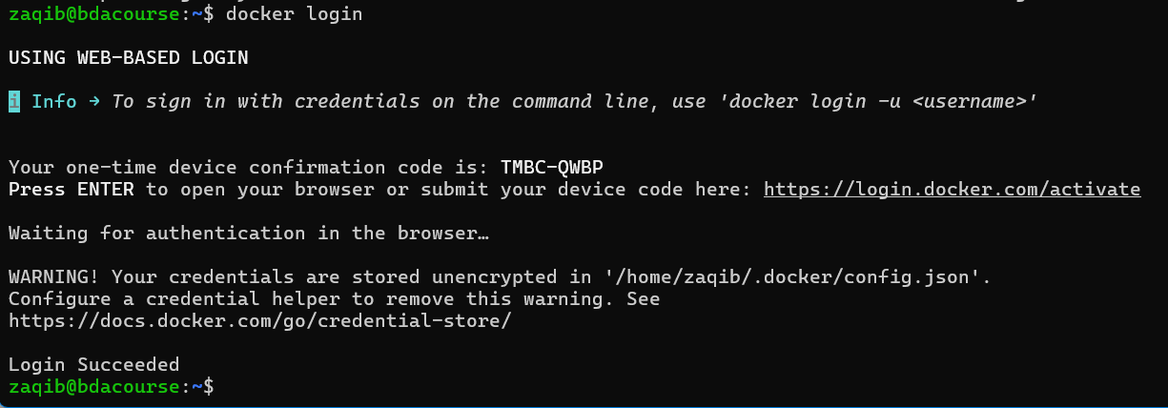

Docker Images

You can also pull images with their tags. To get the latest tag, search for this image from

hub.docker.com and click on “Tags” tab. The latest tag is at the top.

Remember that “Docker Official Image” with any image name on hub.docker.com means

an official image of the Docker company (so it is most reliable). The pull command to use is also specified on the hub page:

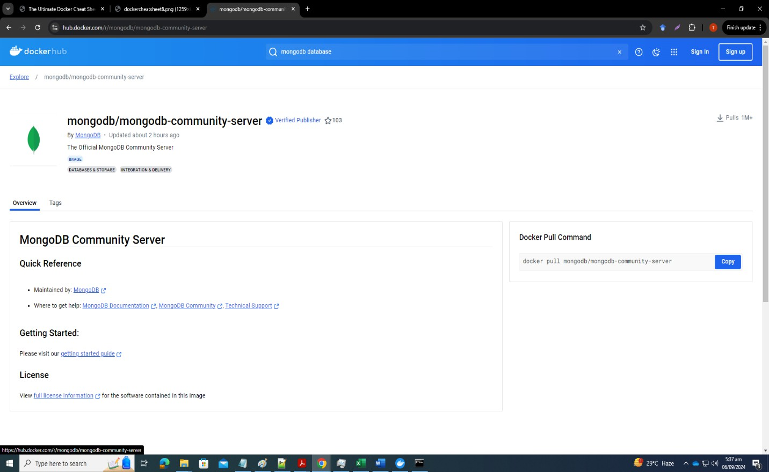

Pull the nginx image: docker pull nginx

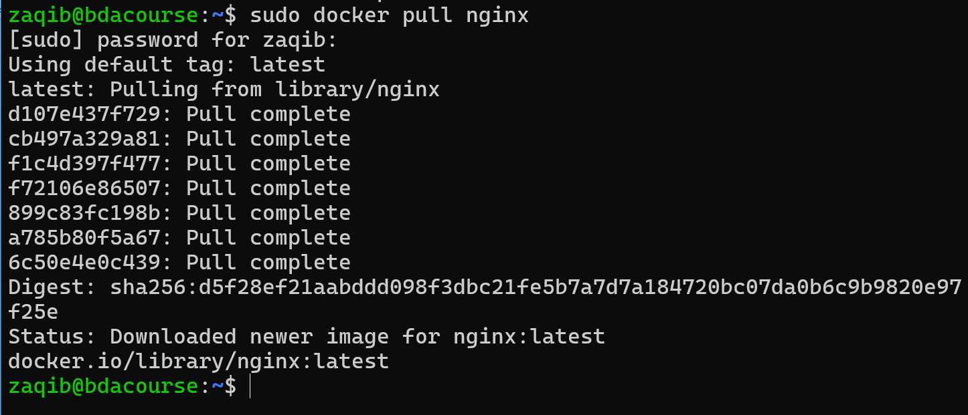

Show list of all downloaded images: docker images (cross-check downloaded image)

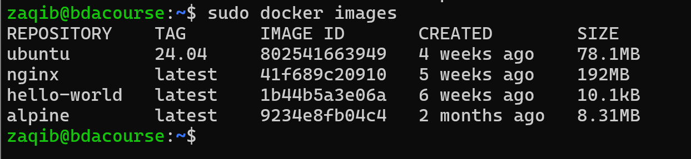

Remove nginx image: docker rmi nginx (some stats will be shown confirming that the image was untagged and then deleted with the SHA256 key – it is a secure hash function with a 64-character hexadecimal number used for data integrity and digital signatures)

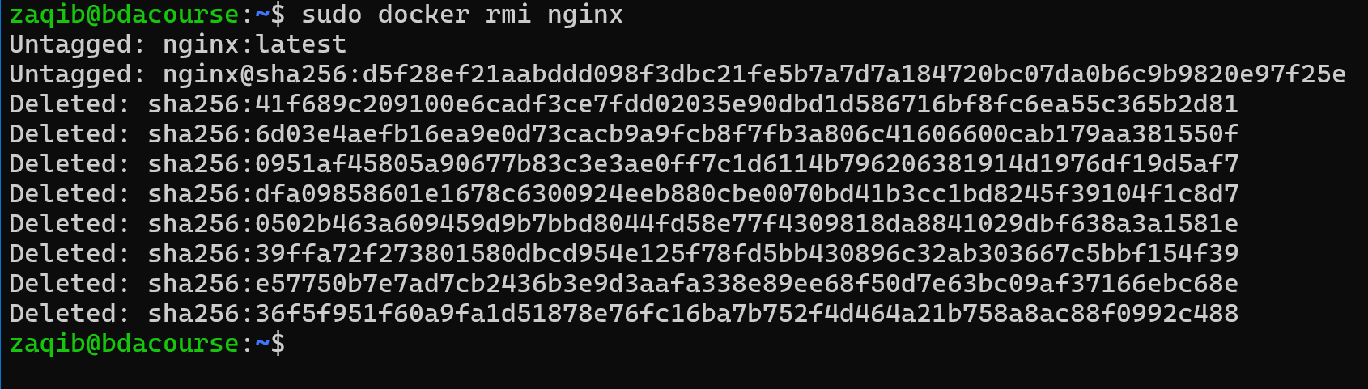

Pull mongodb community server image with specified tag: docker pull mongodb/mongodb- community-server:7.0.2-ubi8 (I copied this from the hub page – you should copy as well since versions and commands may change)

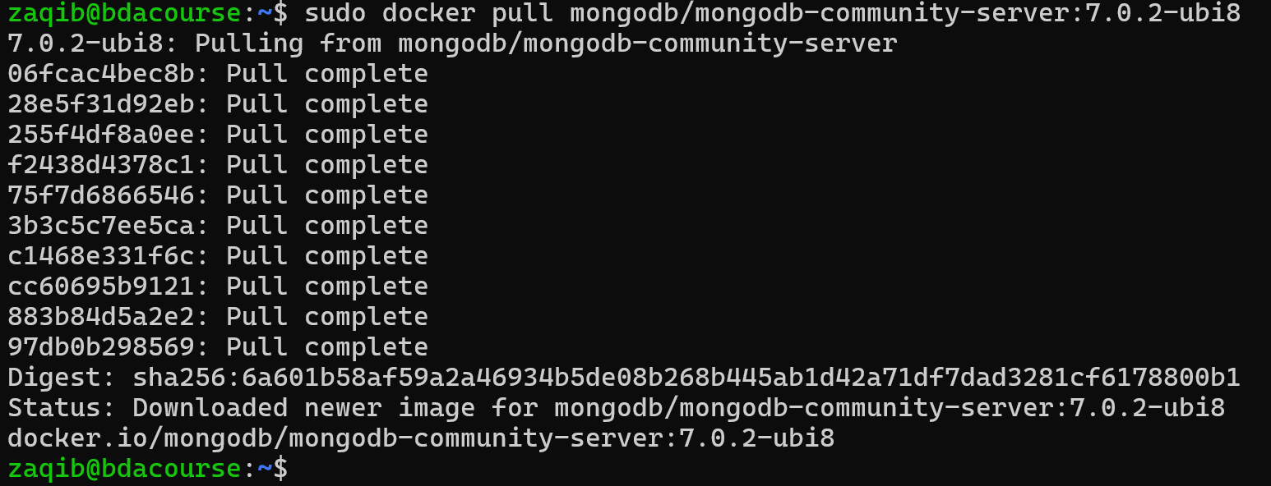

Pull redis image: docker pull redis

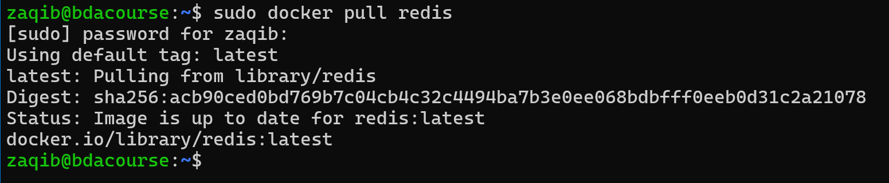

Now check: docker images (how many do you see?)

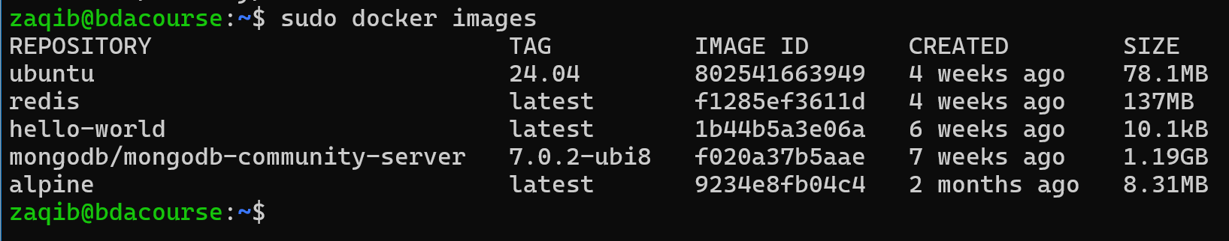Delete dangling images: docker image prune

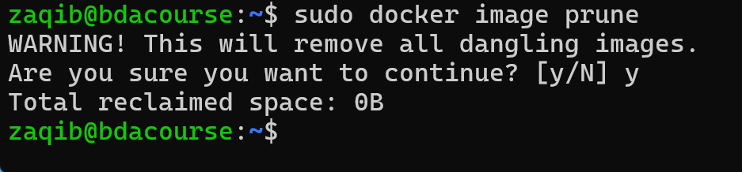

Now check: docker images

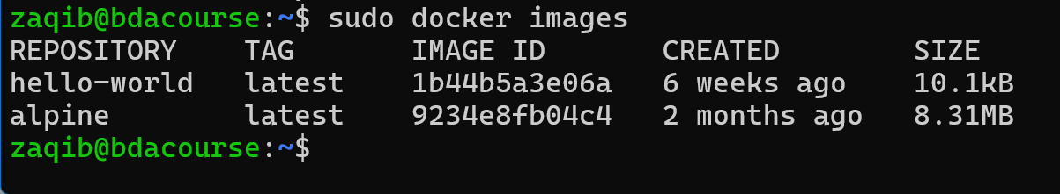

You will see all images you downloaded are still there because none of them is dangling.

A “dangling” image is one that is no longer associated with any tagged repository names. These are intermediate layers that were used in the creation of other images but are no longer needed. Dangling images are identified by <none> tag.

Delete all unused images which do not have any container associated with them: docker image prune -a

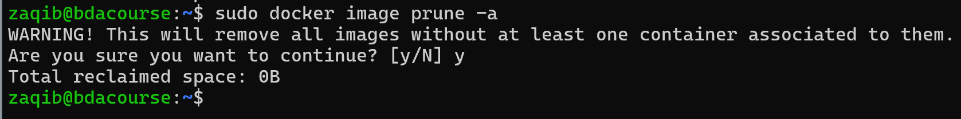

Now check: docker images (All are now removed. So, it is a shortcut to delete all unused ones rather than deleting each separately through rmi command)

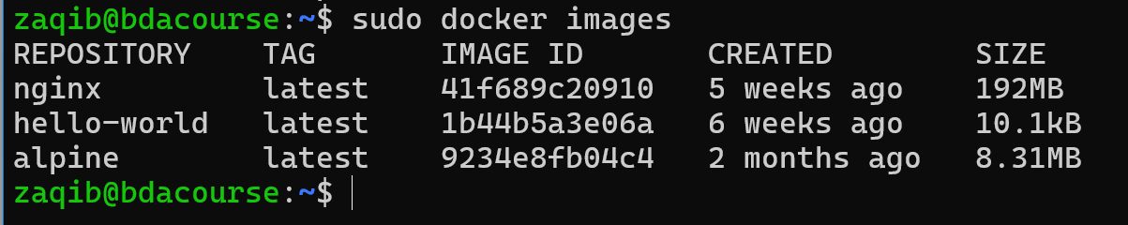

Now pull nginx again: docker pull nginx

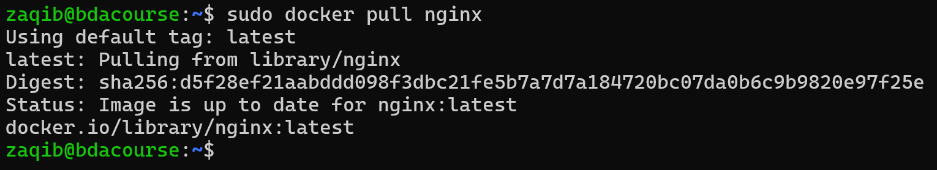

Now check: docker images (it must be tagged with latest)

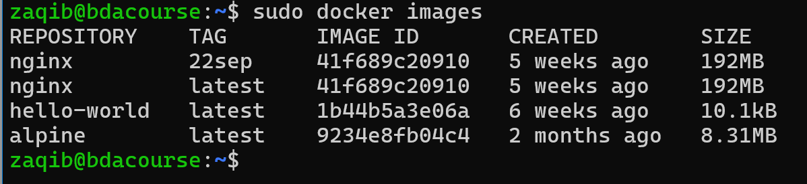Create a new tag: docker tag nginx:latest nginx:22sep

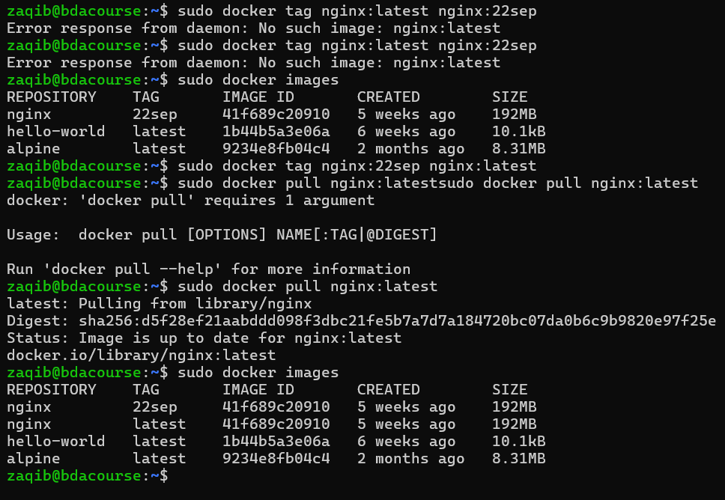

This will just create a reference to the latest tag (not a new copy) Now check: docker images (you will see the two different tags)

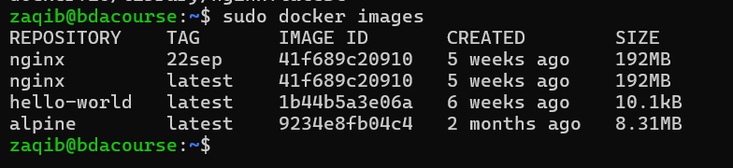Delete it: docker rmi nginx

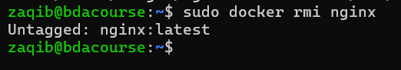

You deleted the original ngnix with latest tag – the reference one remains Check: docker images

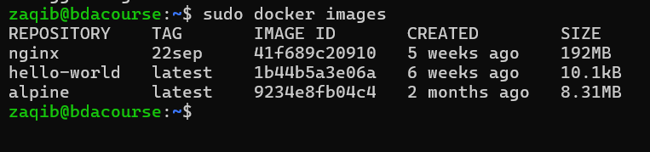

Better to prune: docker image prune -a

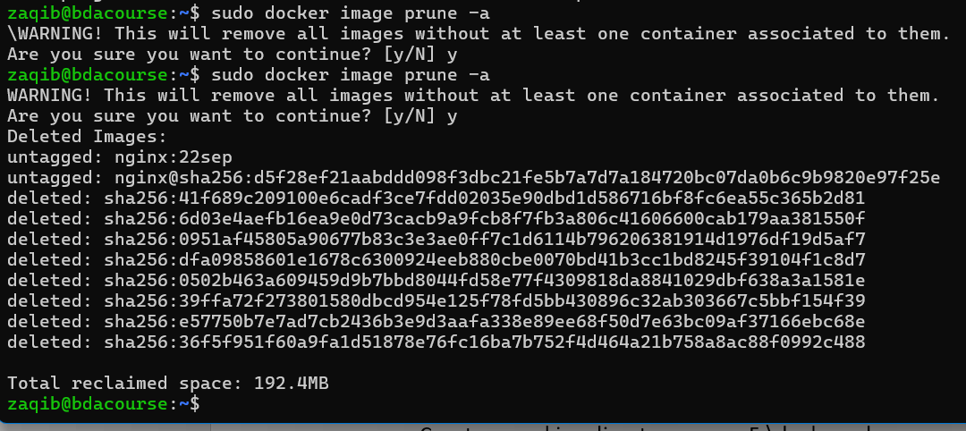

If you want a full cleanup: docker system prune

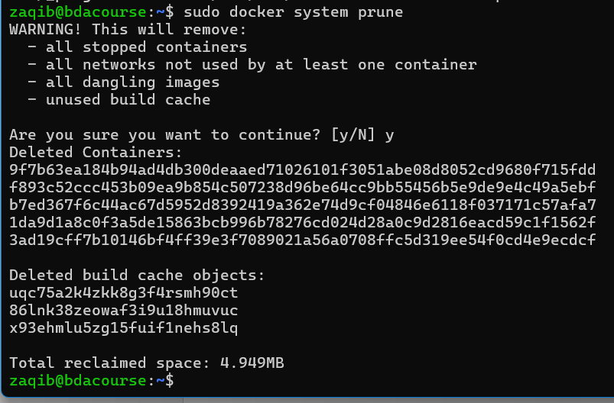

If you want a full cleanup: docker system prune -a (also removes all unused images, not just dangling ones)

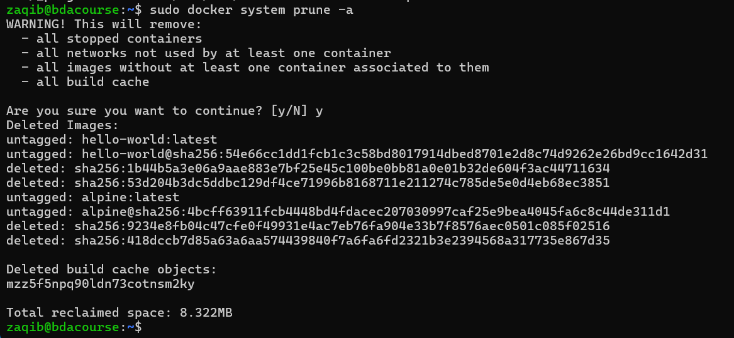

Building an Image:

Now let us do an example to build an image from a Dockerfile.

* Create a working directory – e.g., F:\dockerwd



* Create an html file called index.html in this directory and paste the following content in it

<!DOCTYPE html>

<html lang="en">

<head>

<meta charset="UTF-8">

<title>Simple App</title>

</head>

<body>

<h1>Hello World</h1>

<p>This is running in a docker container</p>

</body>

</html>

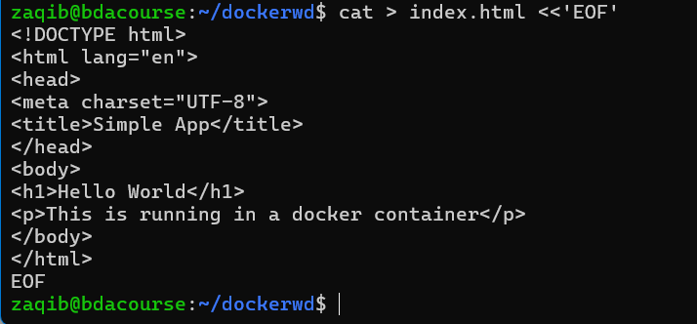

* Save index.html. This is the webpage which will be shown by the webserver nginx in a container

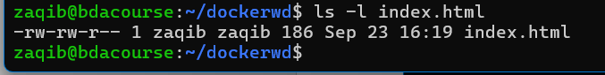

* Access F:\dockerwd on CMD
* Do: docker pull nginx

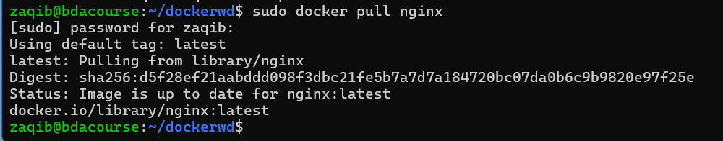

* Now create a file called Dockerfile (make sure it has no extension like txt etc.) in the same directory
* Copy the following content into it

FROM nginx:stable-alpine3.17-slim COPY index.html /usr/share/nginx/html

EXPOSE 80

CMD ["nginx", "-g", "daemon off;"]

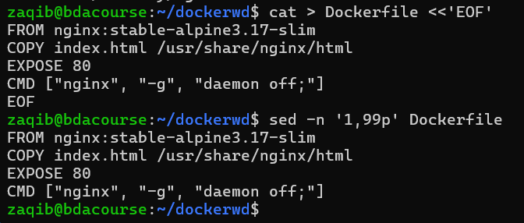

* This will create a Docker image that serves the provided "index.html" file through the Nginx web server when a container is launched based on that image.
* FROM initializes a new build stage and sets the base image for subsequent instructions.
* COPY copies files or directories (usually the source code) from the source to the specified location inside the image. It copies the file to the "/usr/share/nginx/html" directory, which is the default location for serving static files in the Nginx web server.
* The purpose of CMD is to provide defaults for executing containers.
* Now build the image: docker build -t justasample:v1 .

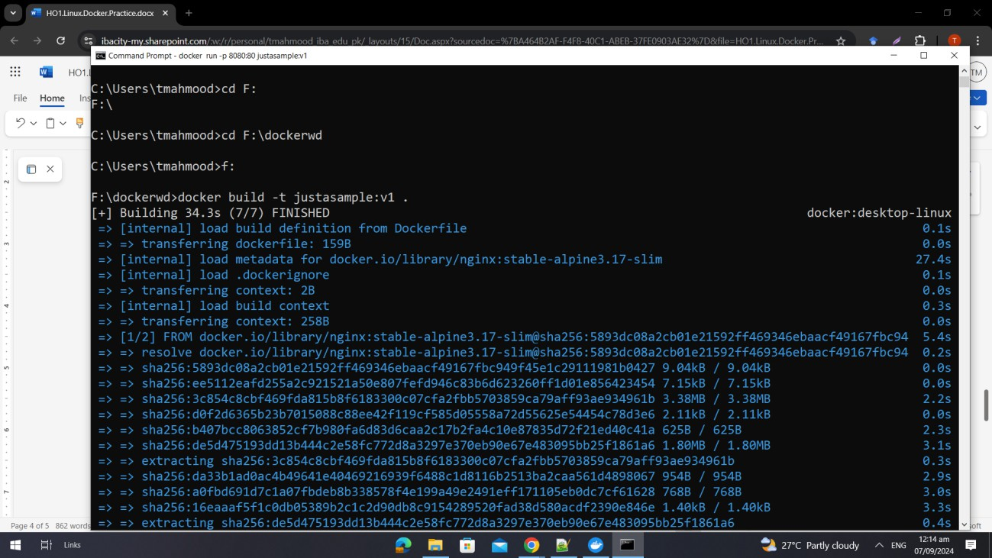

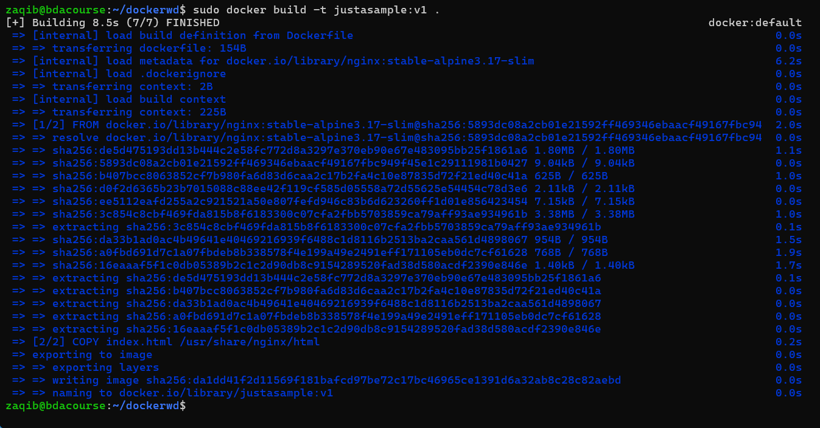

* The -t flag specifies a tag for the image, allowing you to assign a name and version to it. In this case, the image will be tagged as "justasample" with the version "v1" providing a descriptive identifier for the image, making it easier to reference and manage.
* Now check: docker images

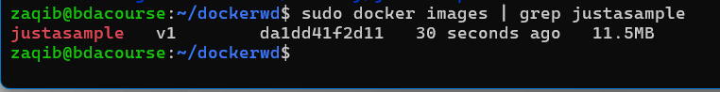

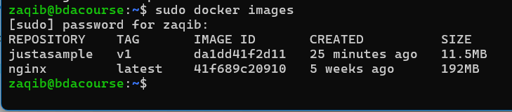

* Now run the container for the image: docker run -p 8080:80 justasample:v1

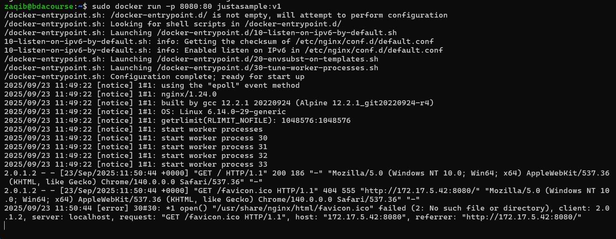

* Note: If a Windows Security Alert pops up, allow it.
* This command tells Docker to run the sampleapp container. The -p flag specifies the port mapping, which maps a port from the host machine to a port inside the container. Here, you are mapping port 8080 of the host machine to port 80 of the container. You can modify the host port as per your preference. Ensure you specify the image name and version you used when building the image.
* Open a web browser and navigate to localhost:8080

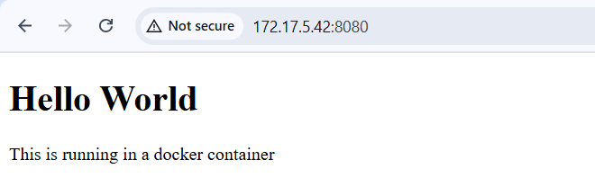

Show the webserver output

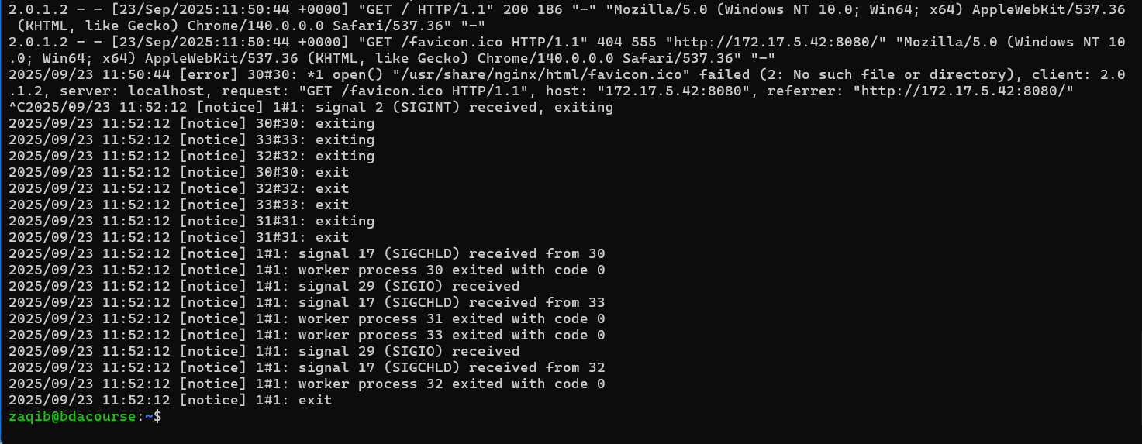

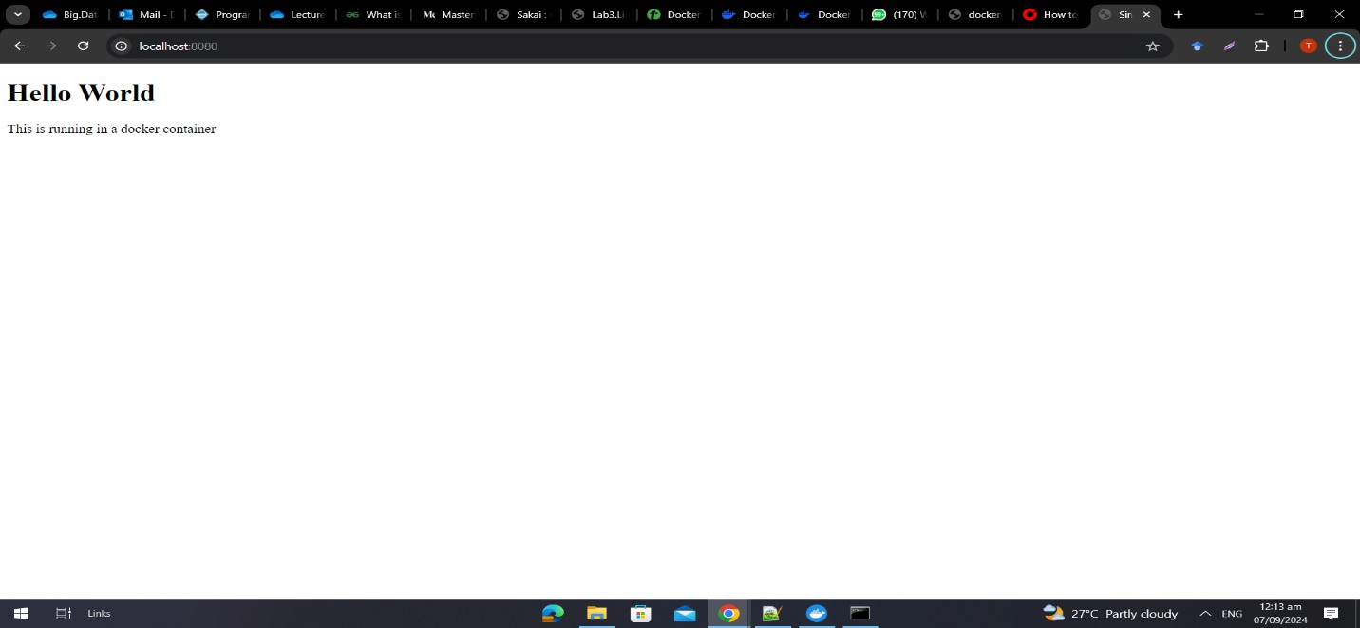

# Tagging Image:

Now tag your image with your repo:

docker tag justasample:v1compadrejaysee/sampleapp:v1

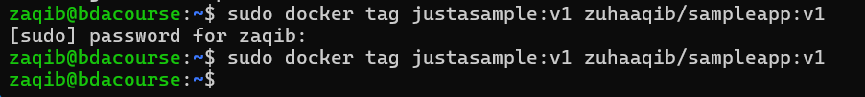



Now push the image to your repo:

docker push justasample:v1compadrejaysee/sampleapp:v1

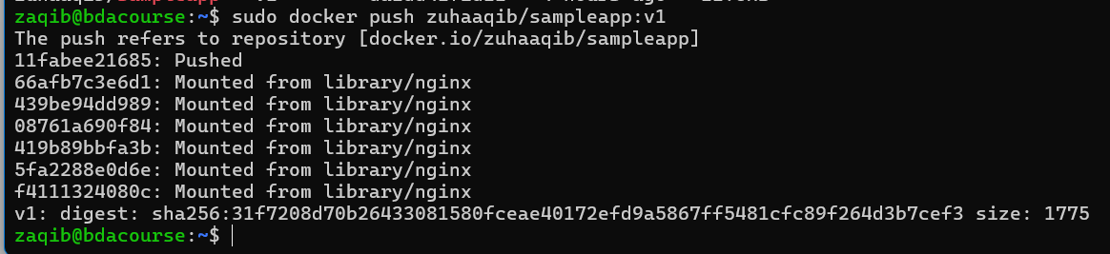

Check out Docker Hub

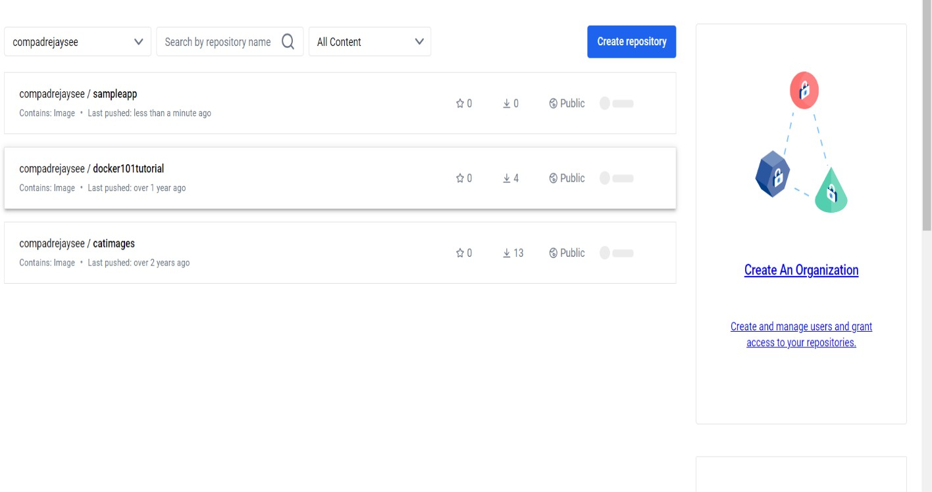

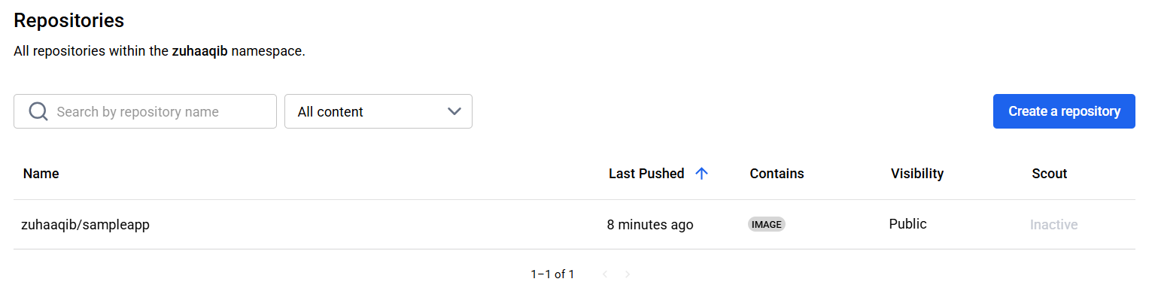

Check also the containers tab on Docker desktop:

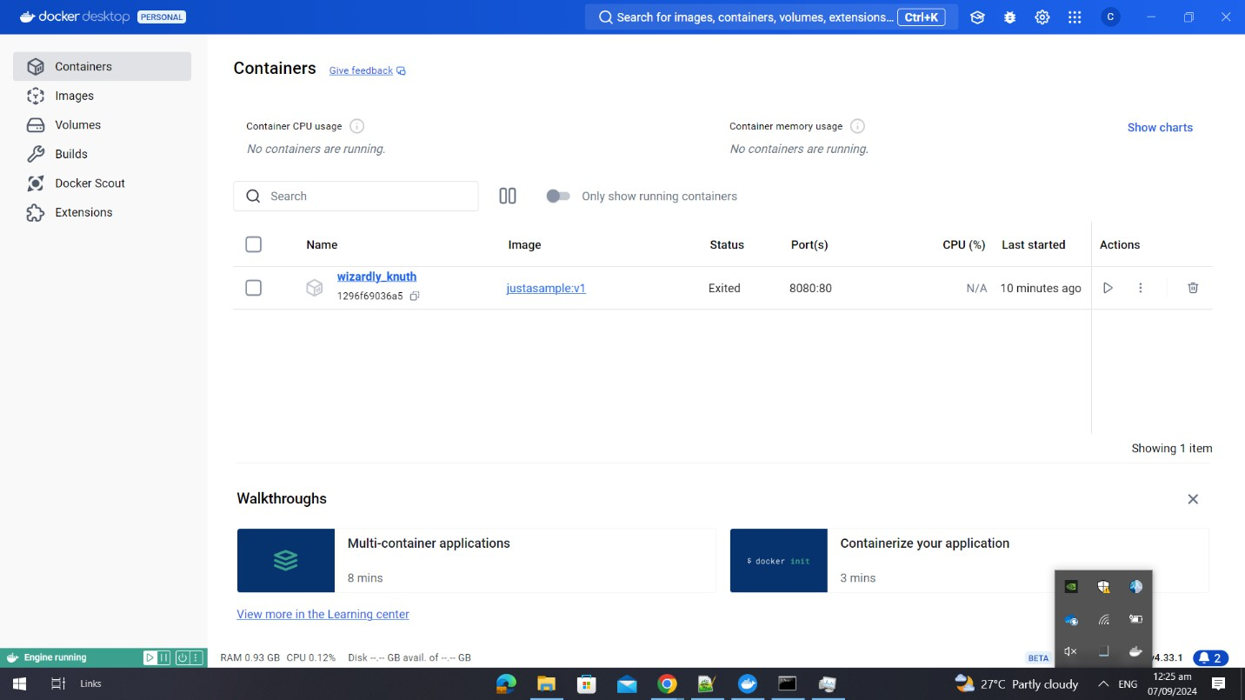

Press Ctrl+C to stop the running container.

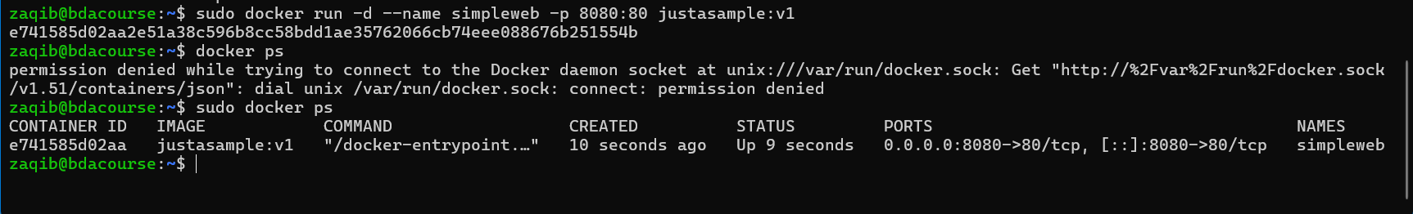

Docker Containers

Pull redis image: docker image pull redis

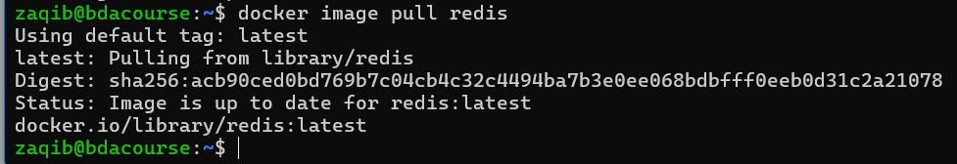

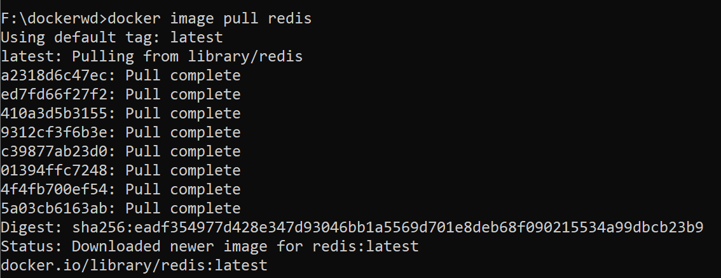

Now check: docker images

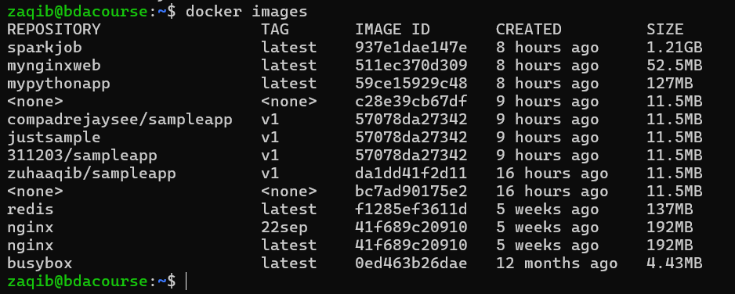

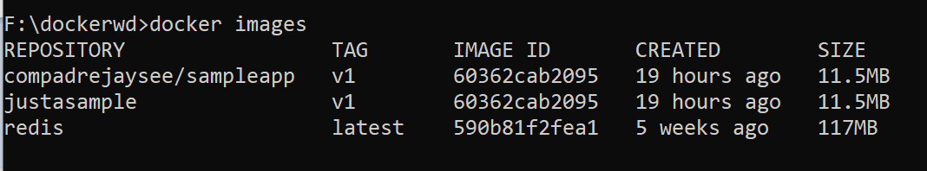

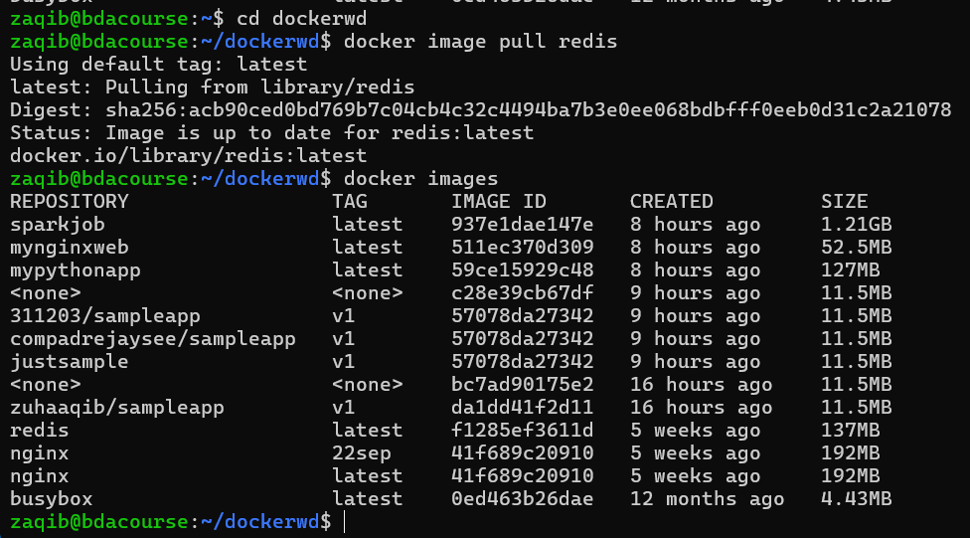

Run the redis container in detached mode: docker run -d --name myredis -p 6379:6379 redis:latest



-d means “detached mode”, i.e., your CMD doesn’t get blocked (like for the sampleapp)

Now run the sampleapp container in detached mode: docker run –d -p 8080:80 justasample:v1

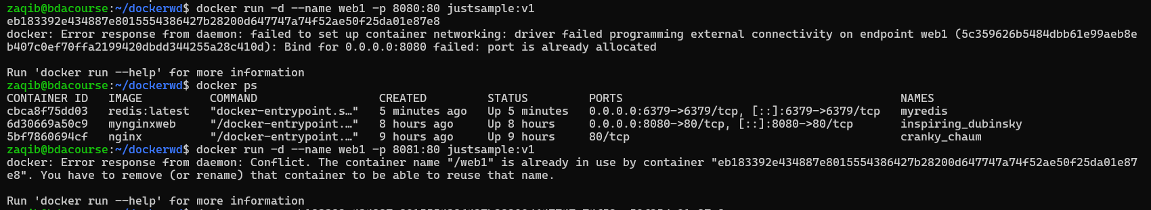

saw that a container is running on port 8080, removed it

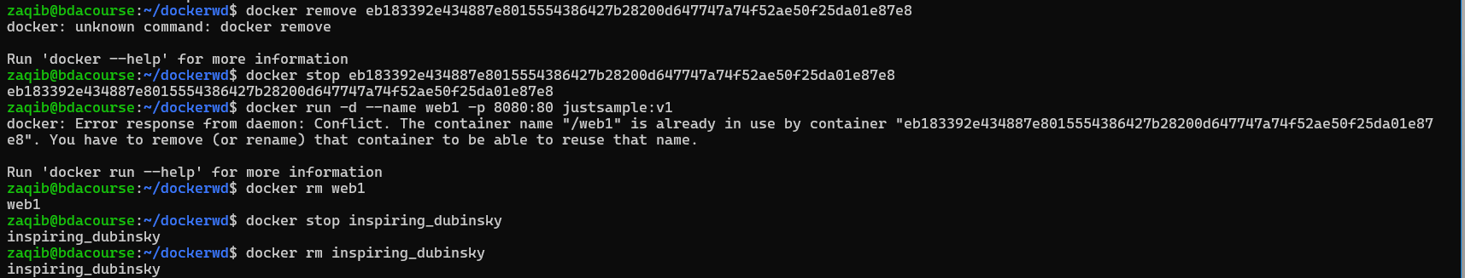

Now lets run our container



Now check the list of all running containers: docker ps



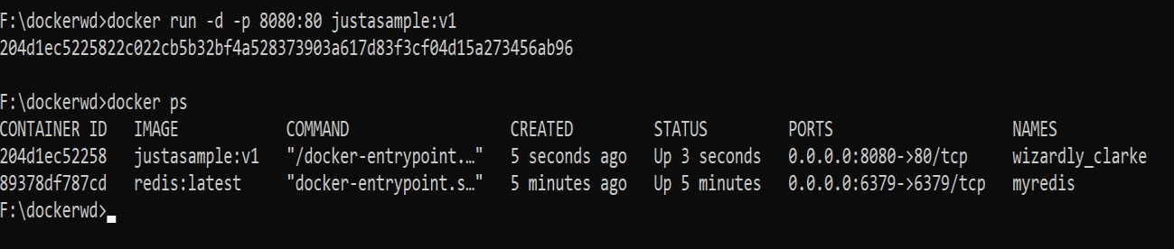

Hash is the containerID. This is a unique, alphanumeric string that Docker assigns to each running container. The full ID is typically 64 characters long, but Docker often displays only the first 12 characters for convenience, as these are usually sufficient to uniquely identify the container among others.

You can use the ContainerID to do many things, stop a running container: Stop the container:

docker stop 204d1ec52258

docker stop 89378df787cd

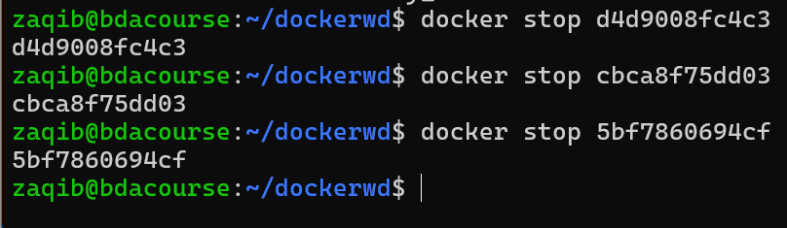

docker ps



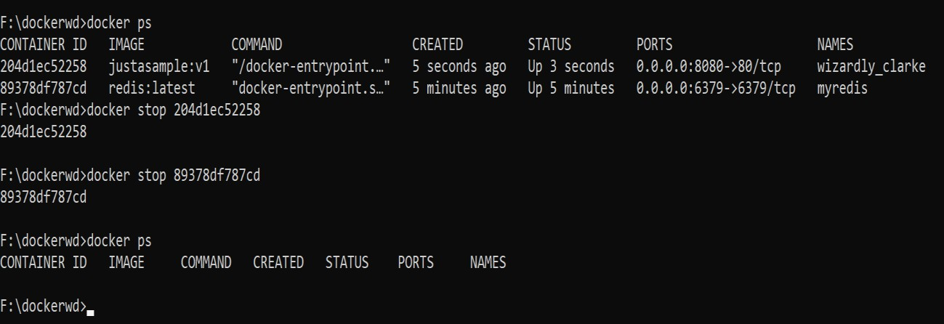

Prune all stopped containers: docker container prune

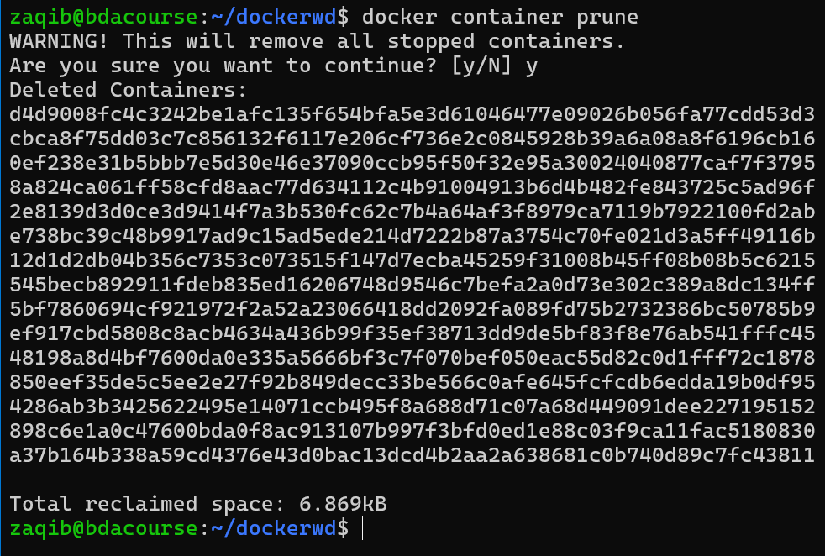

Verify there are no running containers or stopped containers:

docker ps (list of all running containers)

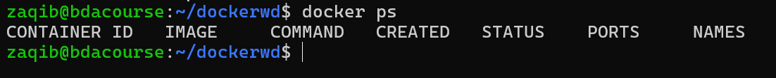

docker ps –a (list of all containers – both stopped and running in a session)



If you don’t do this, and run the Redis container again with the same name, it might give an error (because a container which has been run once and stopped remains in repo unless it is completely removed through prune or through rm)

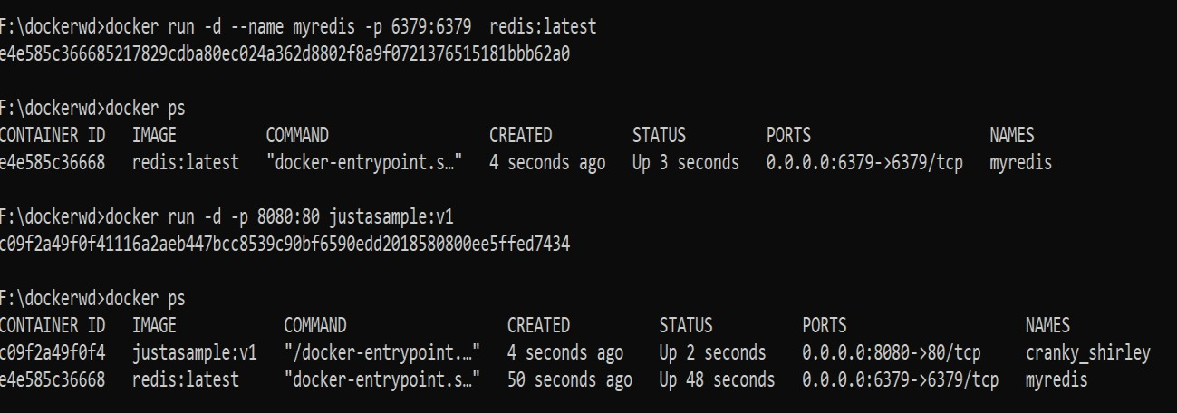

You can see that Docker itself assigns weird or humorous names to containers (if you don’t

assign it)

See the logs of a container:

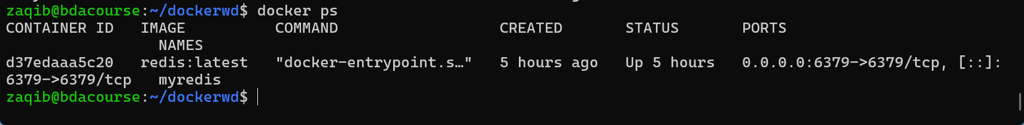docker logs c09f2a49f0f4 docker logs e4e585c36668

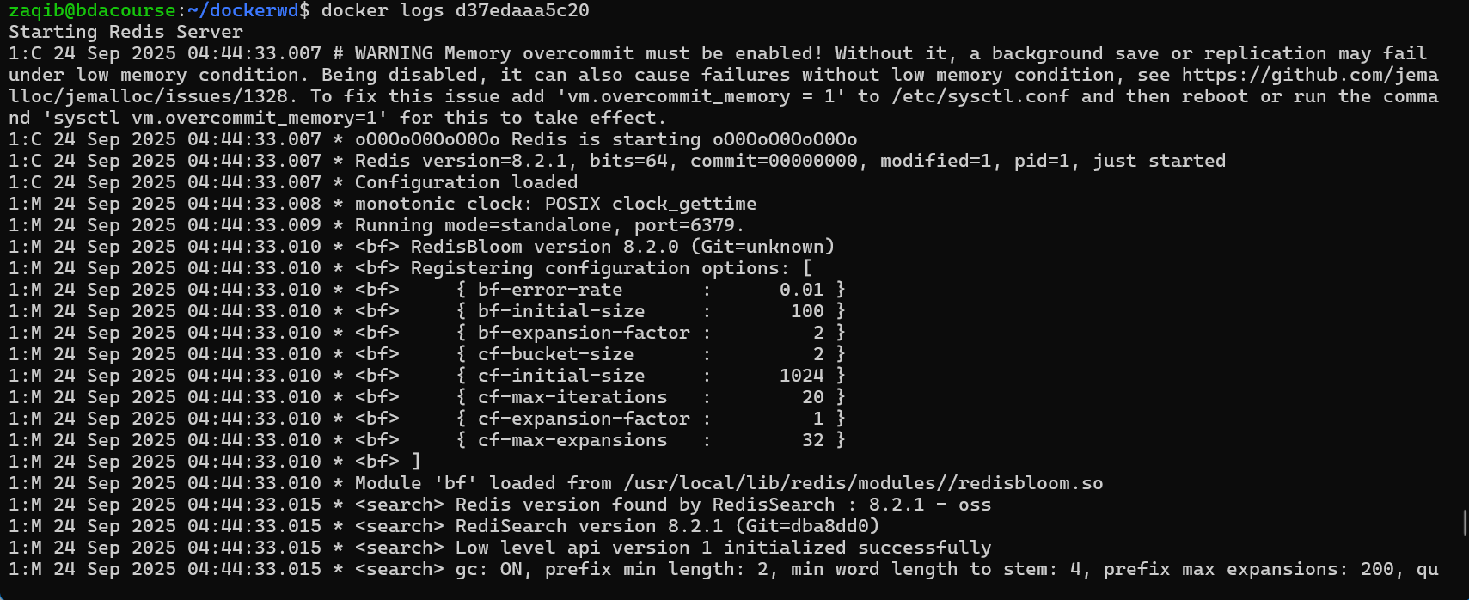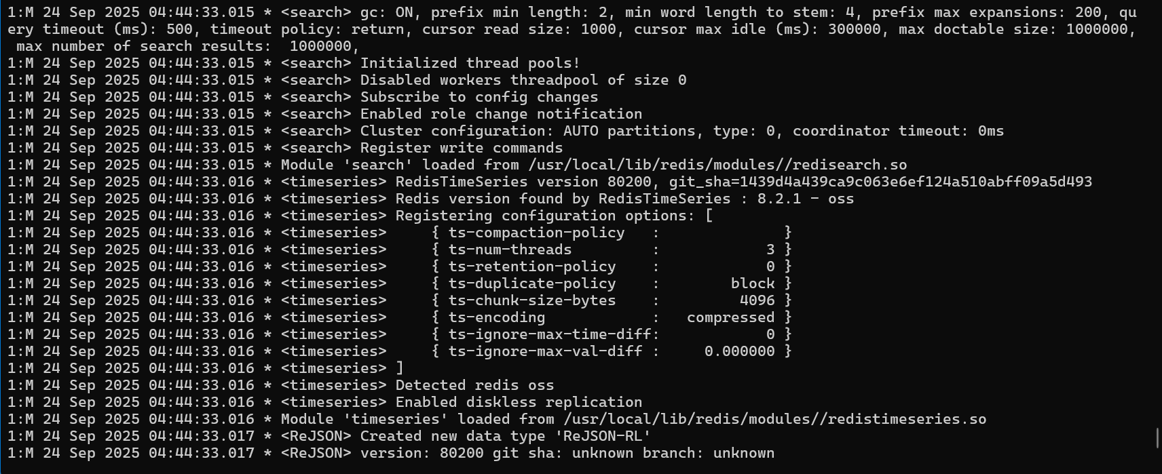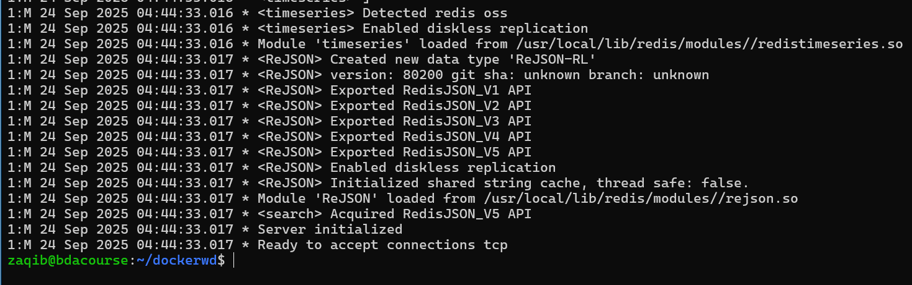

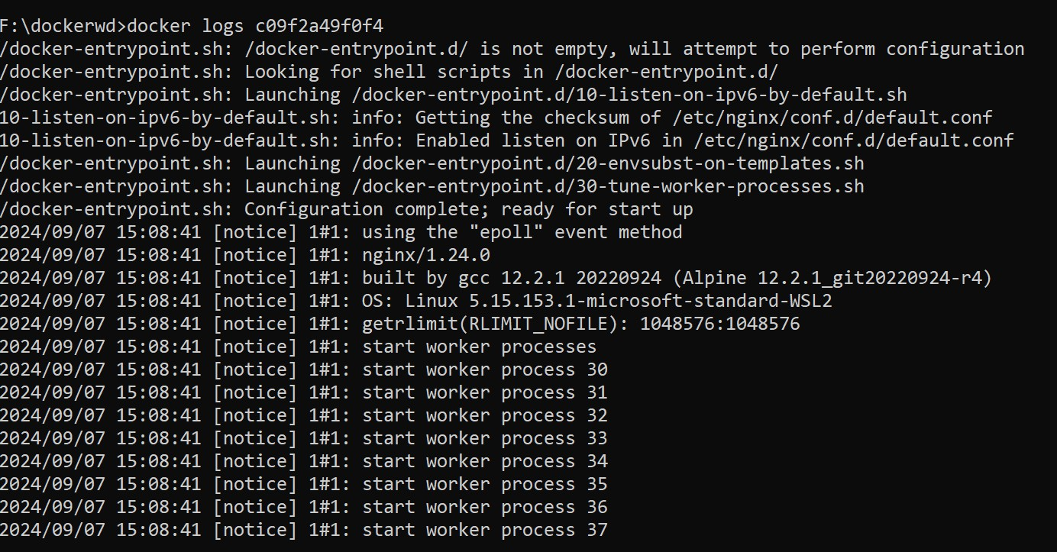

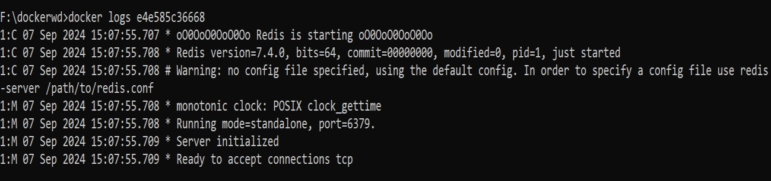

Now stop both containers with rm command:

Delete a running container: docker rm -f e4e585c36668 and docker rm –f c09f2a49f0f4

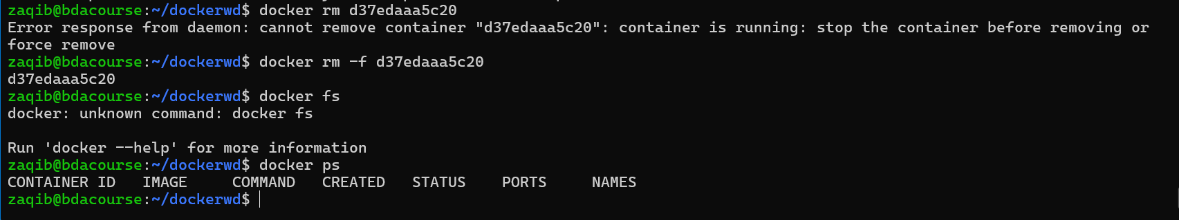

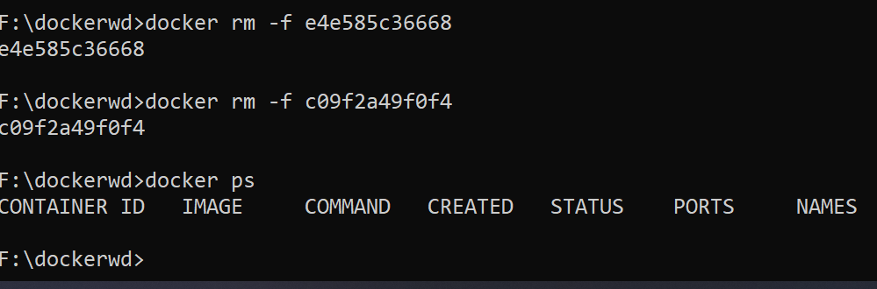

Run the container again: docker run -d -p 8080:80 justasample:v1

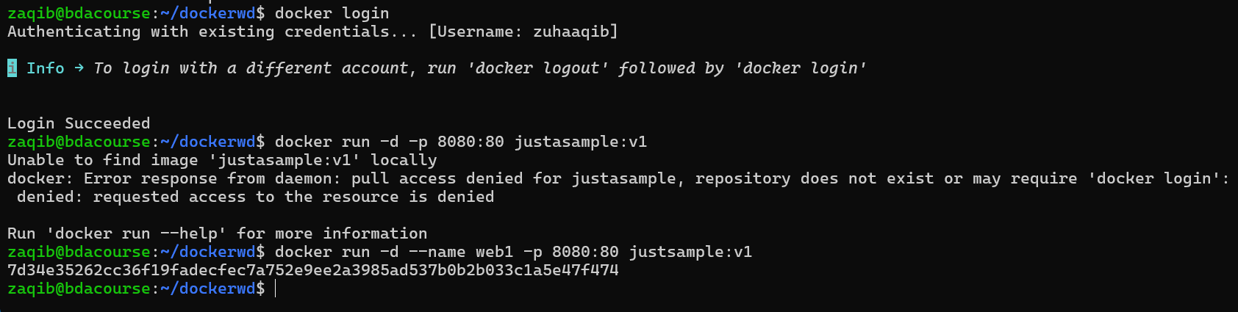

Check it running and get id: docker ps

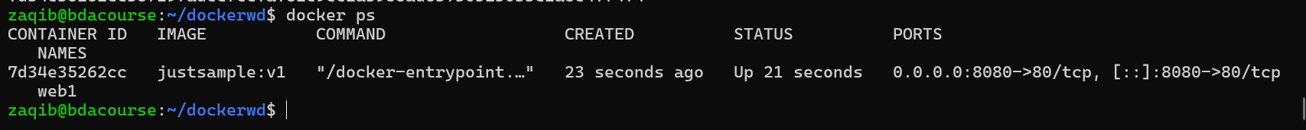

Now stop it: docker stop <containerid>

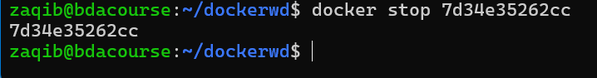

Check it's not running: docker ps

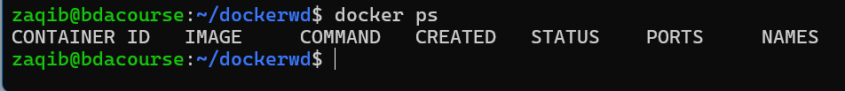

But it's in the repo: docker ps –a



Now start it: docker start <containerid>

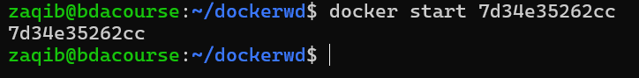Check it running: docker ps



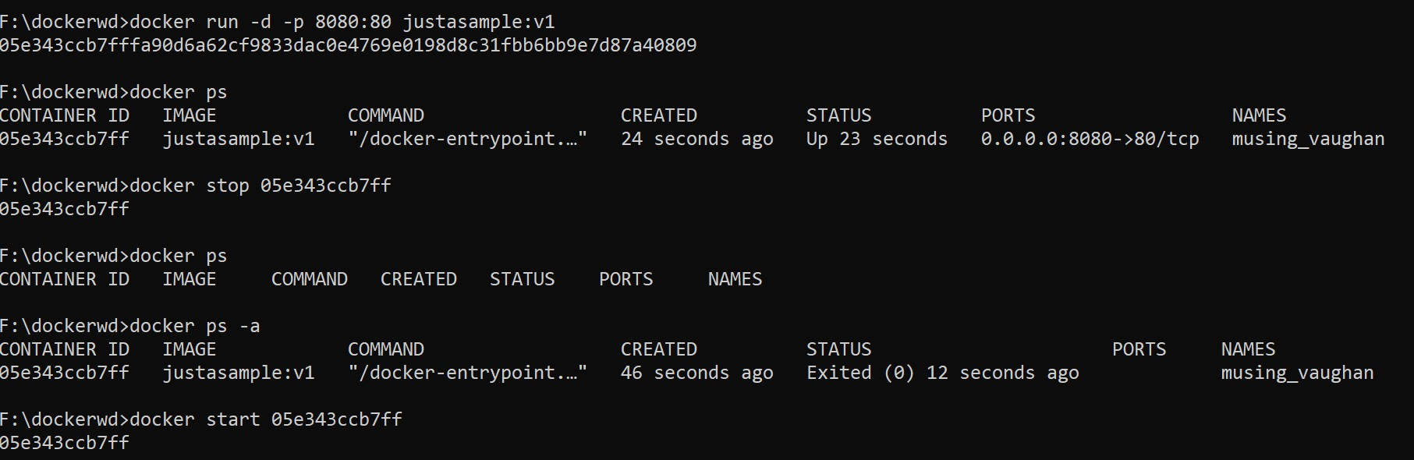

At any time, you can get information about docker through docker info

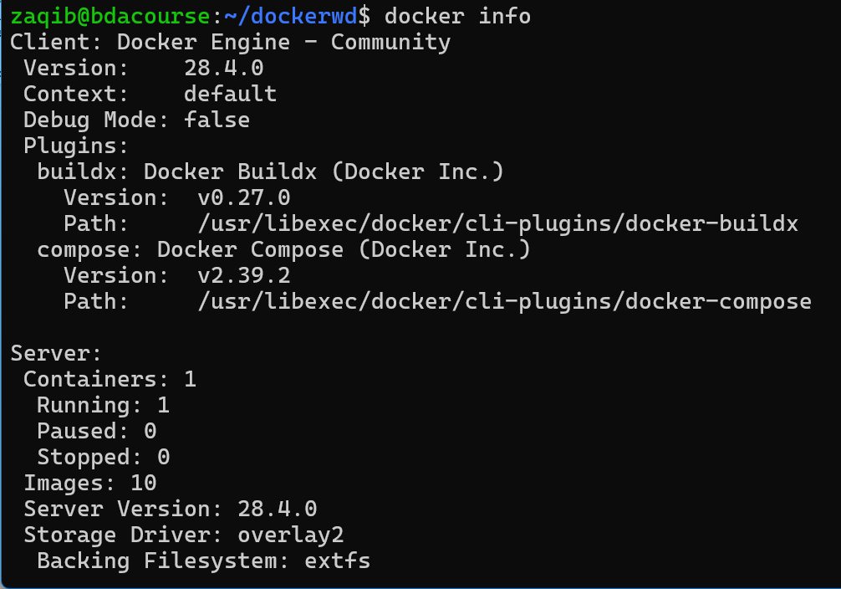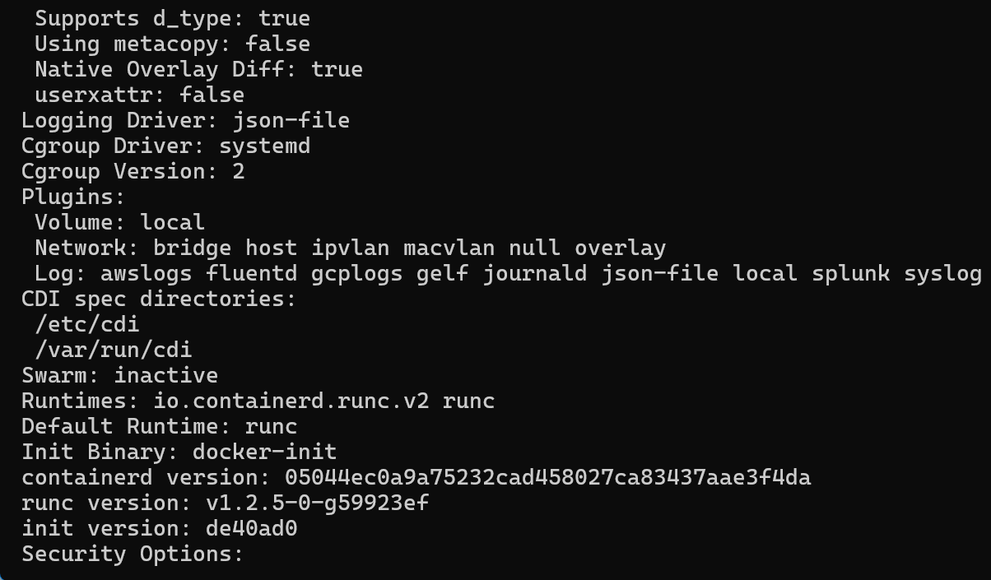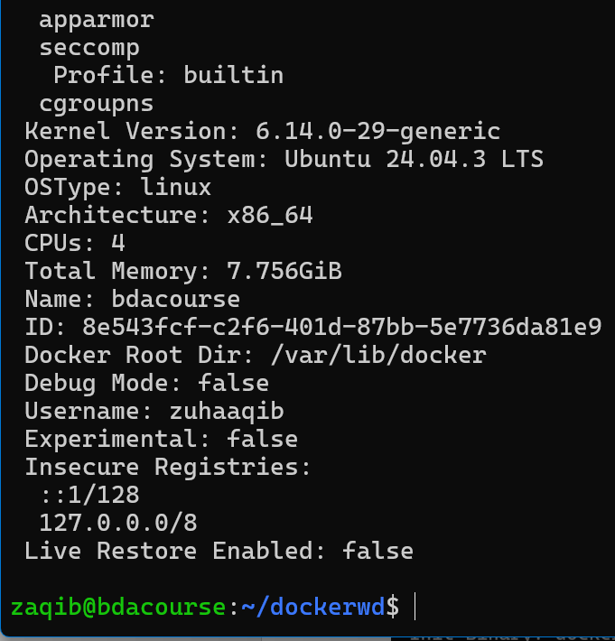

: This will provide information about docker clients and server backends:

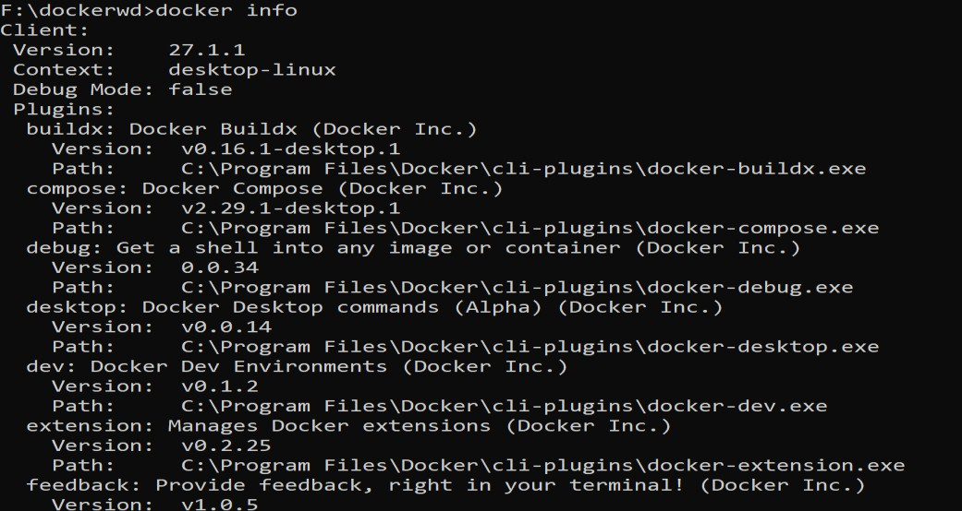

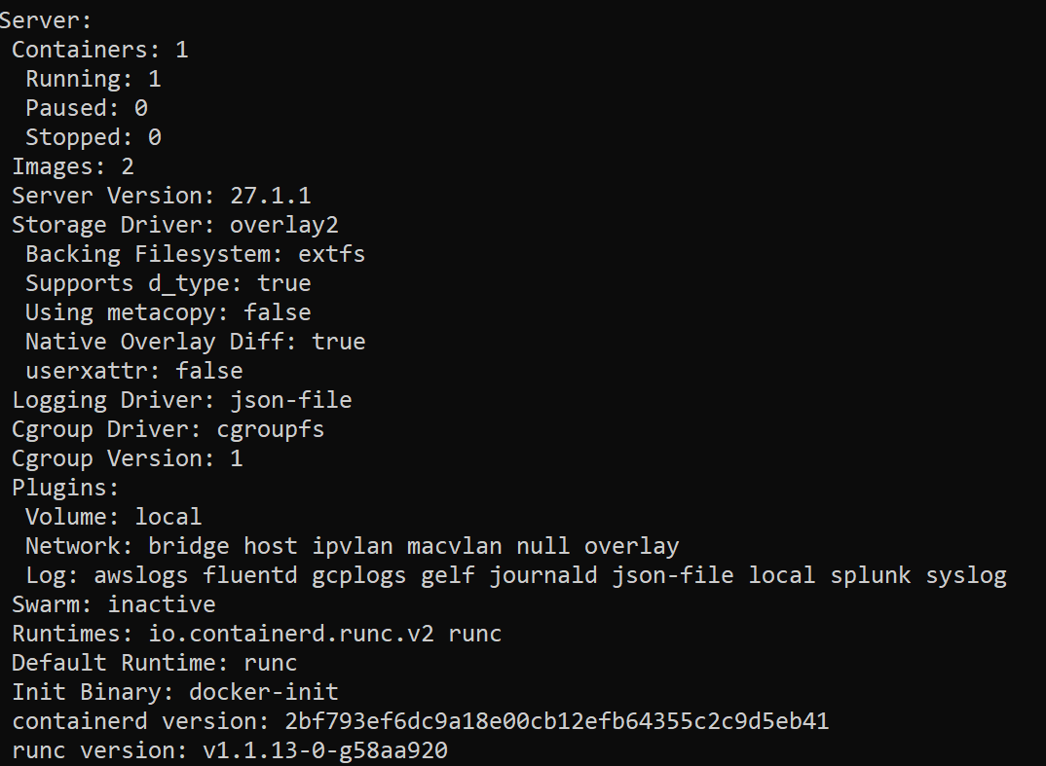

Now, let's try copying file from container to host Download nginx: docker pull nginx

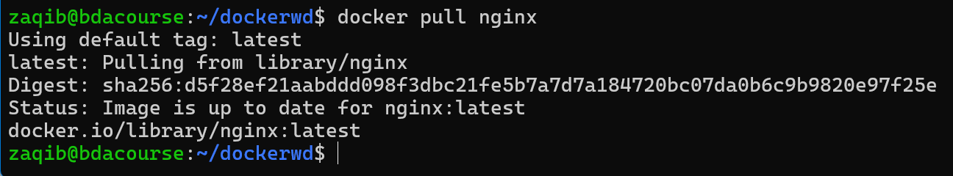

Run a container in the background: docker run –d nginx



Check the container id through docker ps: 69e7fe04f1a0

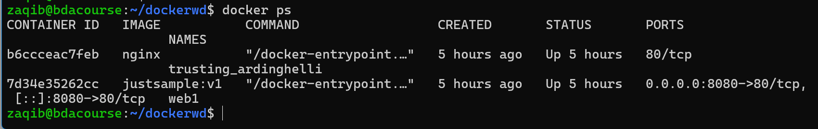

Copy the nginx config file from inside the container to the Windows host: docker cp 69e7fe04f1a0:/etc/nginx/nginx.conf F:/dockerwd

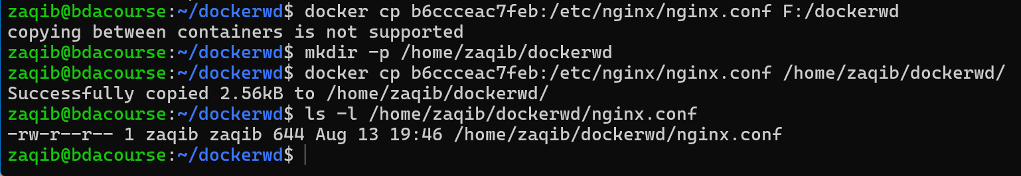

Verify:

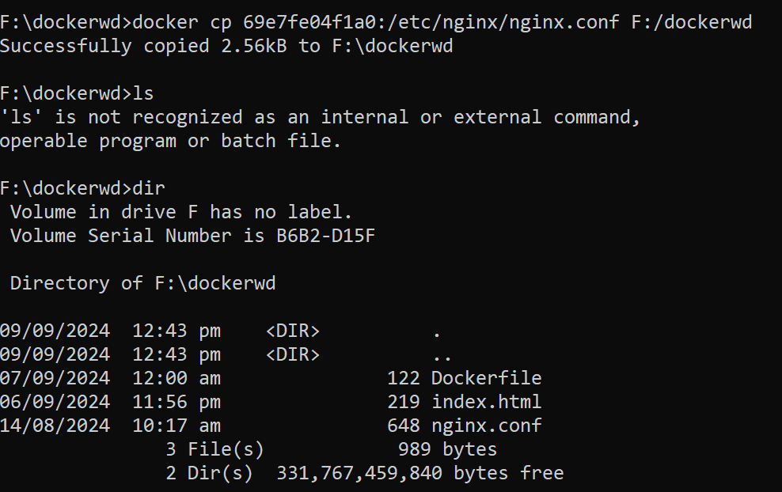

Now, lets copy from the host into the container:

Make a file check.txt in your WD



Copy it inside the nginx container:

docker cp F:/dockerwd/check.txt 69e7fe04f1a0:/etc/nginx



Should show a success message

Bash into the nginx container: docker exec –it 69e7fe04f1a0/bin/bash Search for directories: ls

Access /etc/nginx and verify your file within

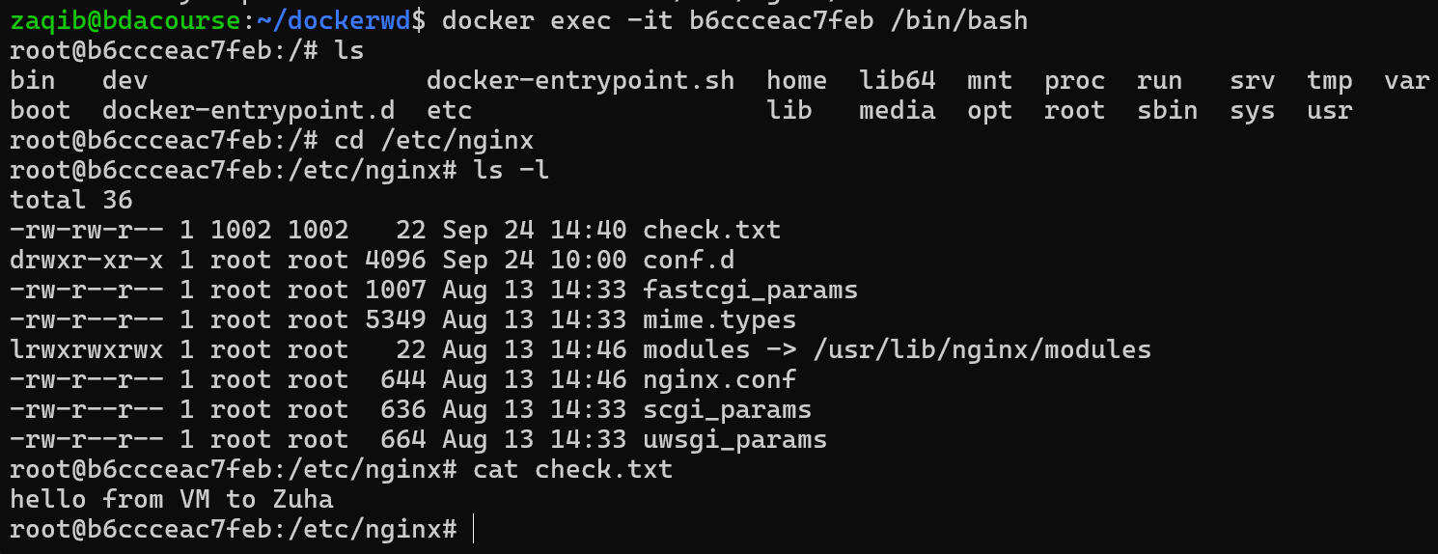

Docker Storage:

Docker supports three main types of storage:

1. Volumes → managed by Docker (/var/lib/docker/volumes/).
2. Bind Mounts → link host paths into containers.
3. tmpfs Mounts → in-memory only (useful for speed, temporary data) – like mounting an ephemeral file system into Docker.

## Basic

Try out the following commands within any container of your choice and provide the output.

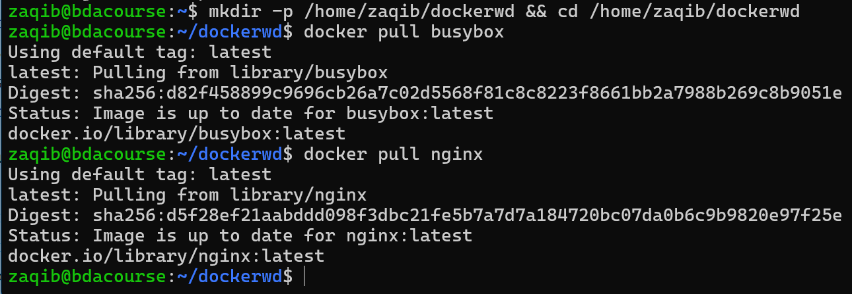

# Create a named volume

docker volume create myvol

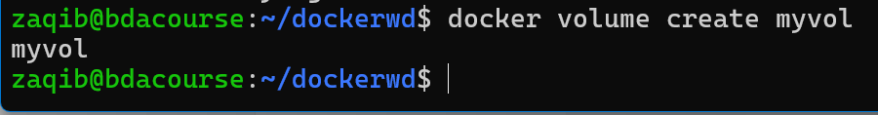

# List all volumes

docker volume ls

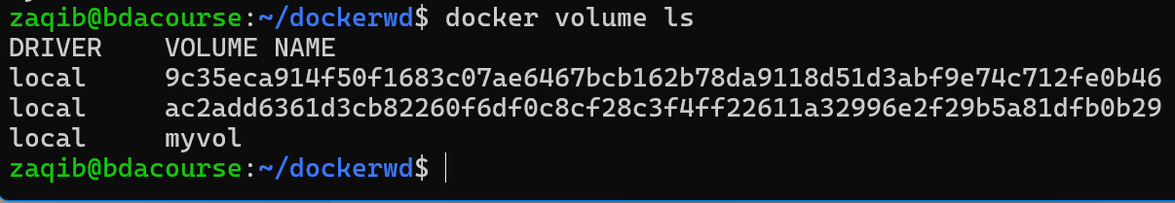

# Inspect a specific volume (path, usage, driver)

docker volume inspect myvol

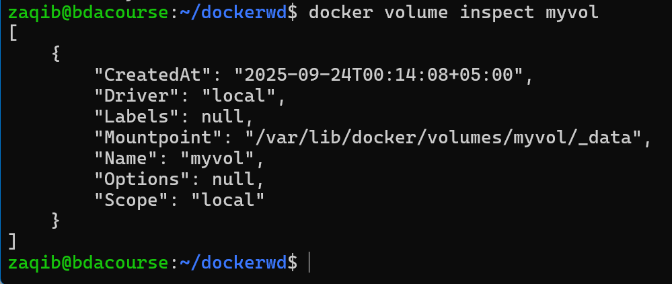

# Remove one or more volumes

docker volume rm myvol

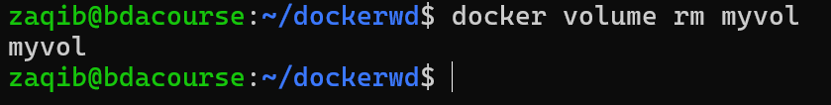

# Remove all unused volumes

docker volume prune

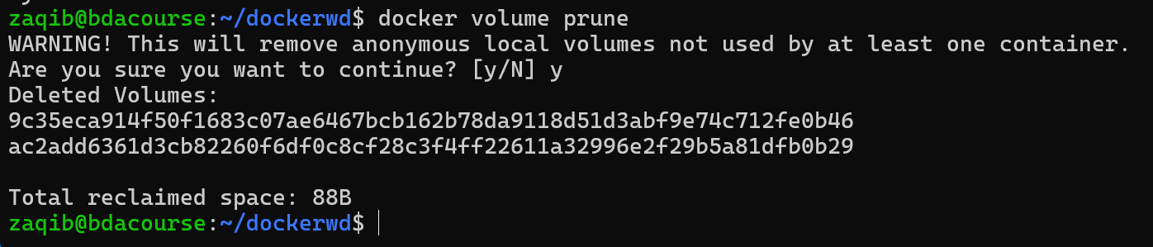

## Using Volumes within Containers

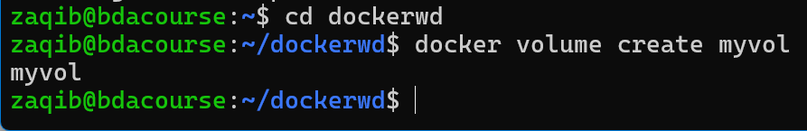

docker run -d \

--mount source=myvol,target=/app/data \

--name mount_container \

busybox sleep 3600

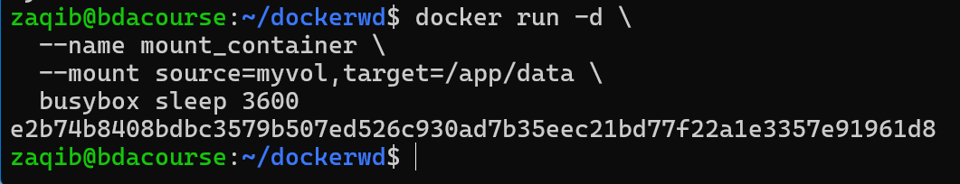

Write into the mounted path from inside the container

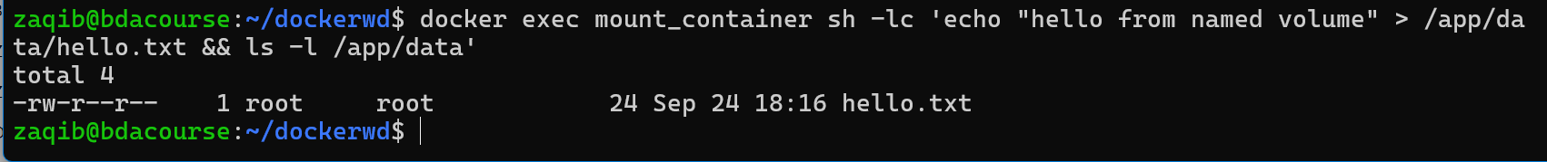

Verify on the HOST that the file is persisted in the volume’s Mountpoint



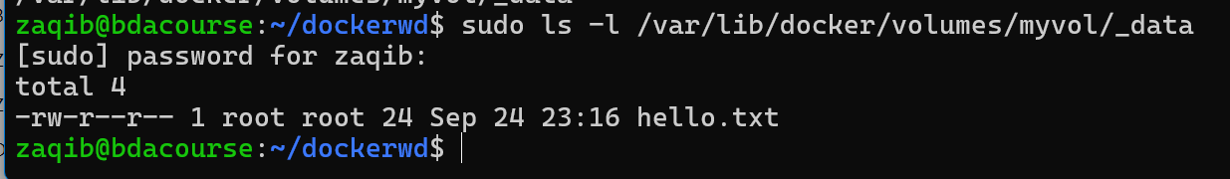

Extra: --mount type=volume,source=myvol,target=/data,readonly

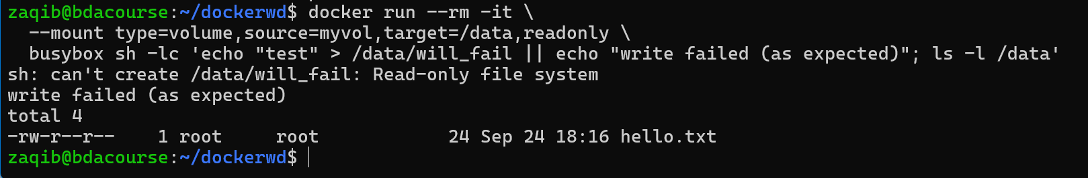

## Bind Mounts

Bind mounts link an existing host directory/file to a container.



docker run -d \

-v /home/user/data:/container/data \

--name bind_container \

busybox sleep 3600

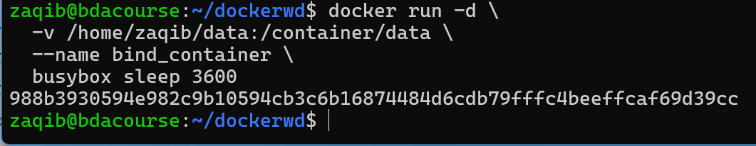

LIST THE MOUNTED FILES

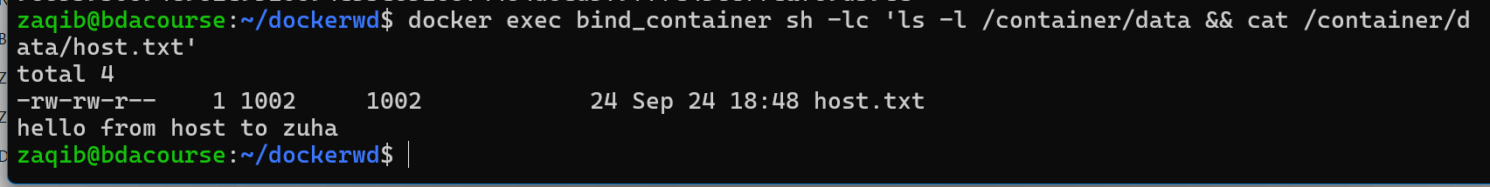

Check: docker run -d -v /logs:/var/log:ro nginx (host **logs** mounted read-only into container)

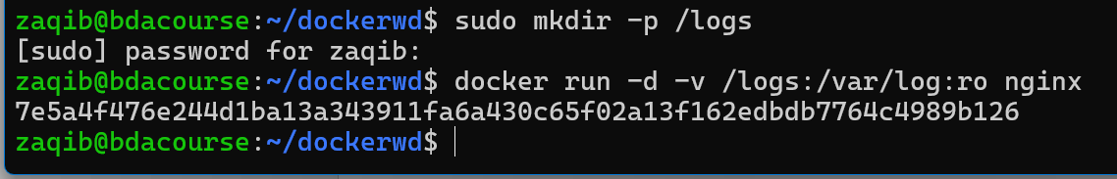

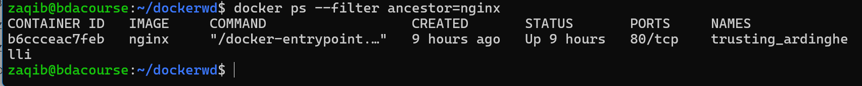

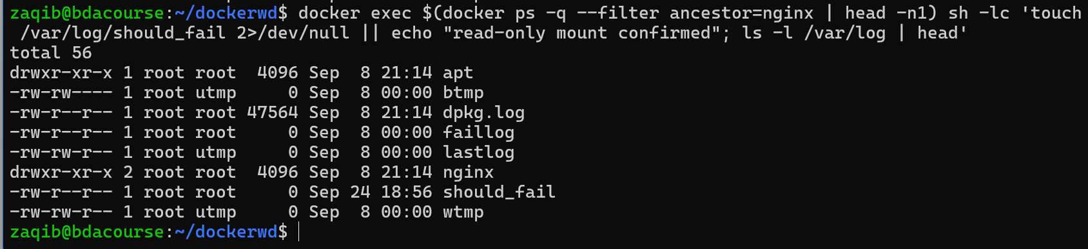

Dockerfile Examples

## Simple Python App:



# Base image

FROM python:3.9-slim

# Metadata

LABEL maintainer="teacher@bda.edu"

# Set working directory

WORKDIR /app

# Copy source code

COPY requirements.txt .

RUN pip install -r requirements.txt

COPY app.py .

# Run app

CMD ["python", "app.py"]

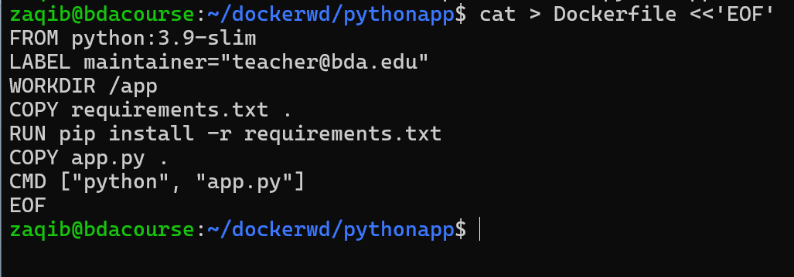

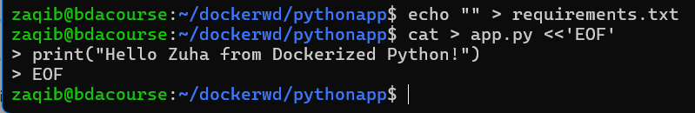

docker build -t mypythonapp .

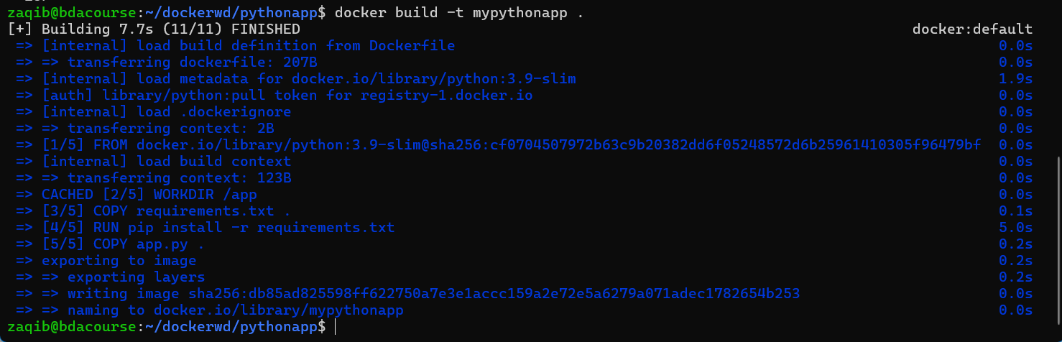

docker run --rm mypythonapp



## Web Server:



FROM nginx:alpine

COPY ./html /usr/share/nginx/html

EXPOSE 80

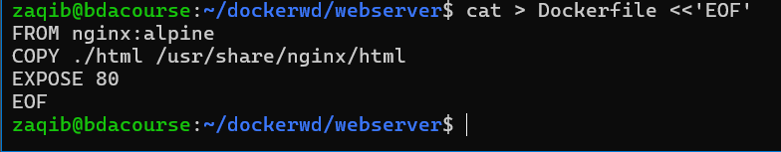

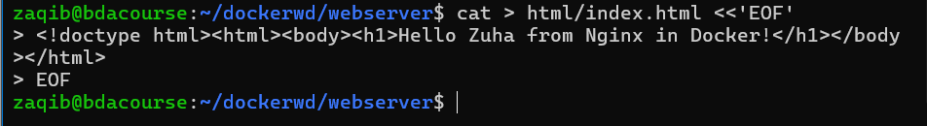

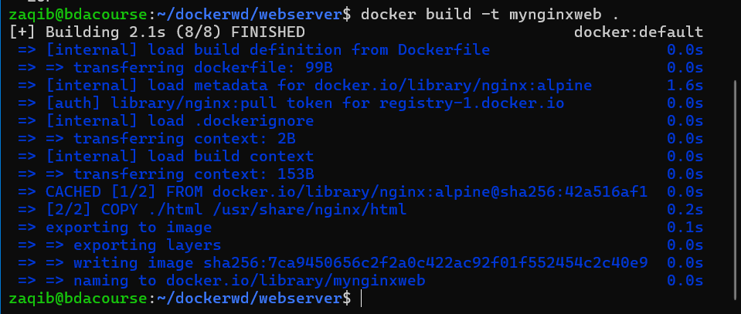

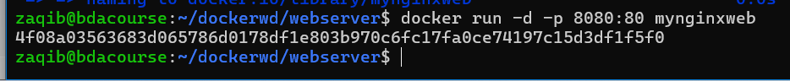



## Spark Job in Docker:



FROM bitnami/spark:latest

WORKDIR /app

COPY wordcount.py .

CMD ["spark-submit", "wordcount.py", "hdfs://namenode:9000/input.txt", "hdfs://namenode:9000/output"]

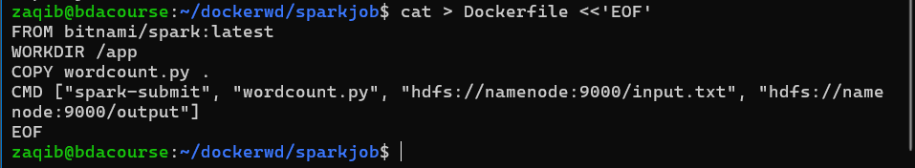

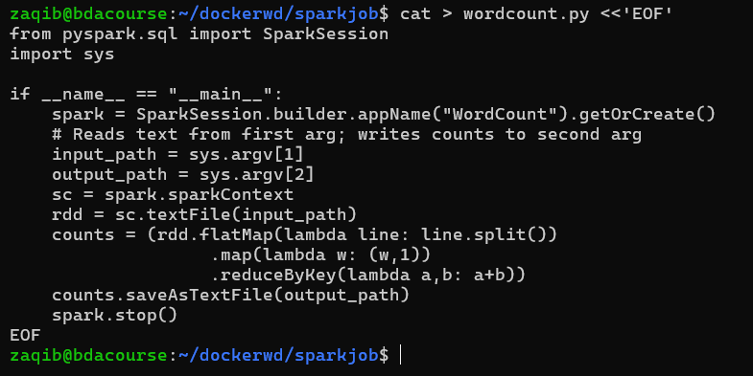

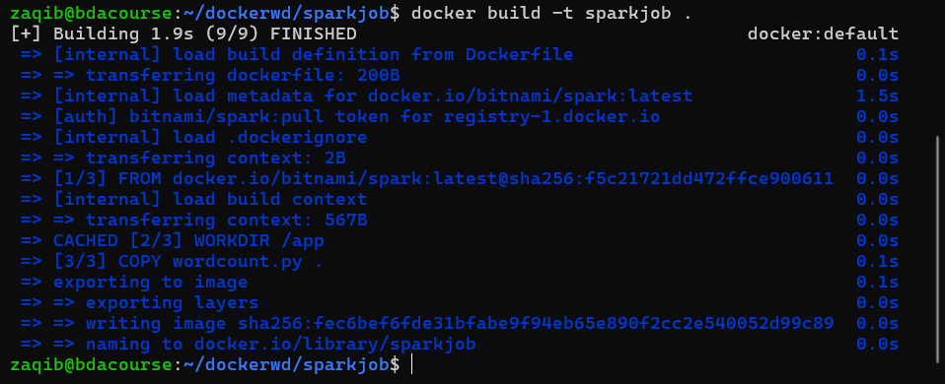

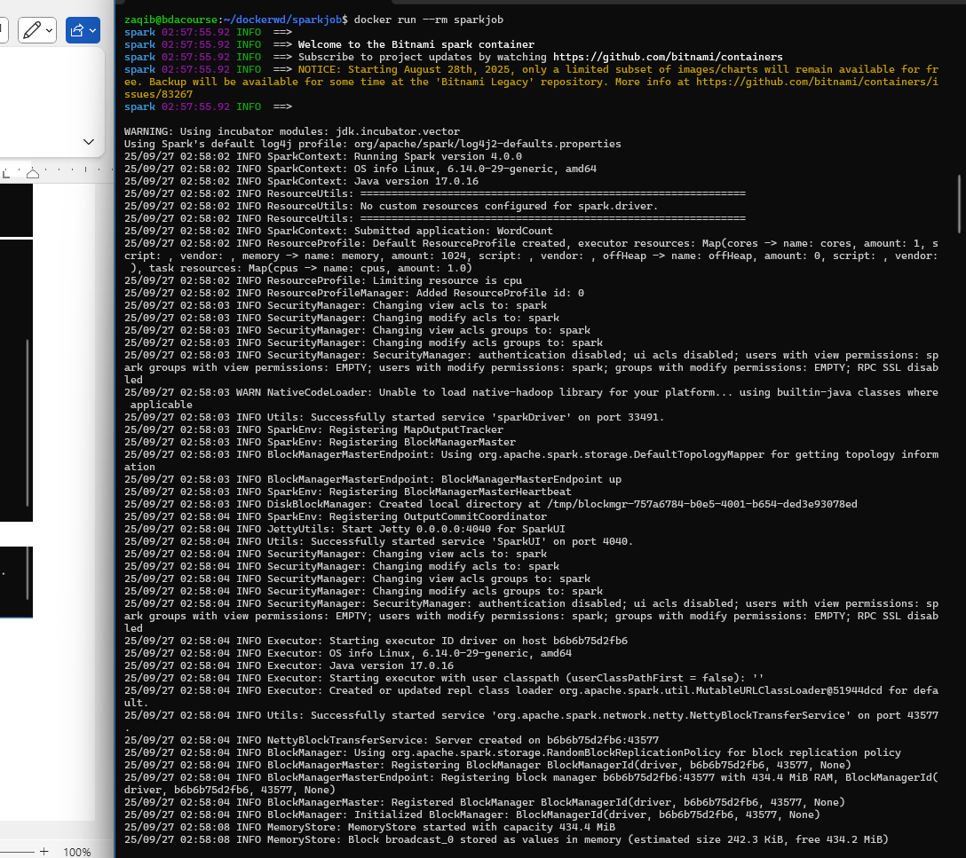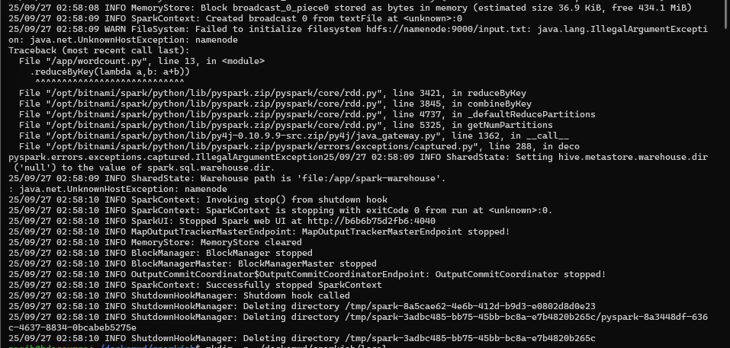

Doesn’t work as no HDFS. Switched locally

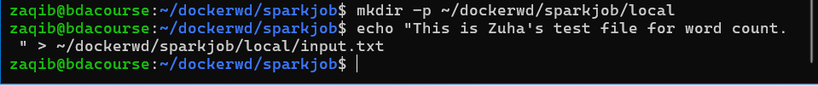

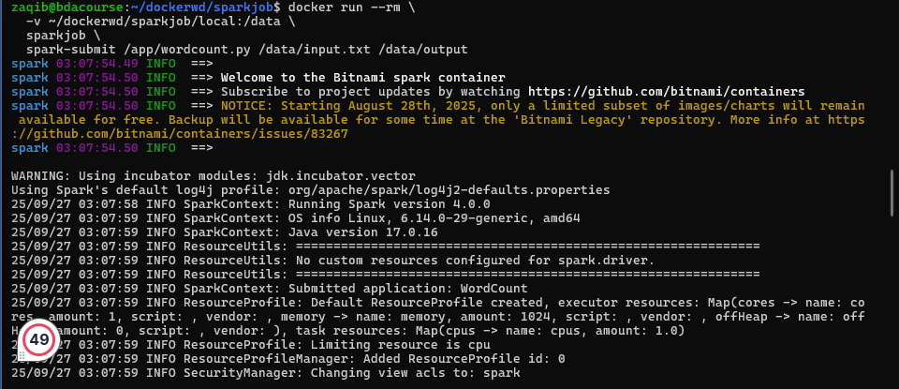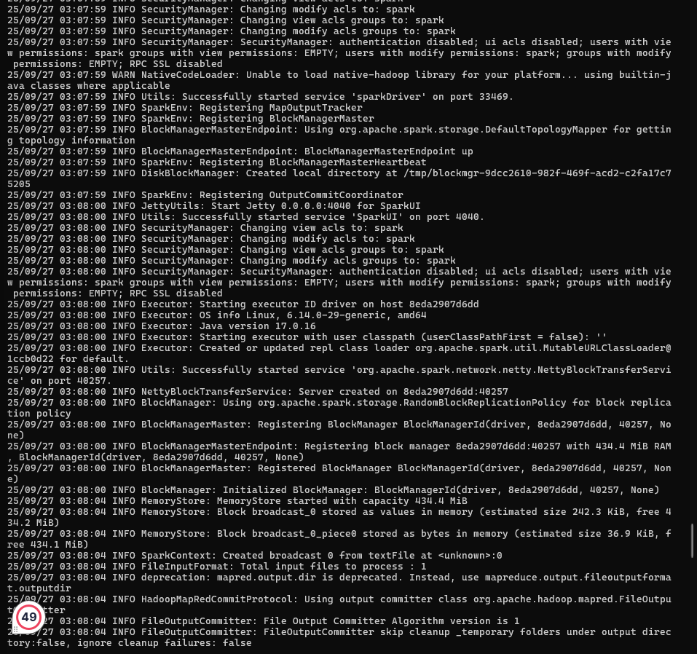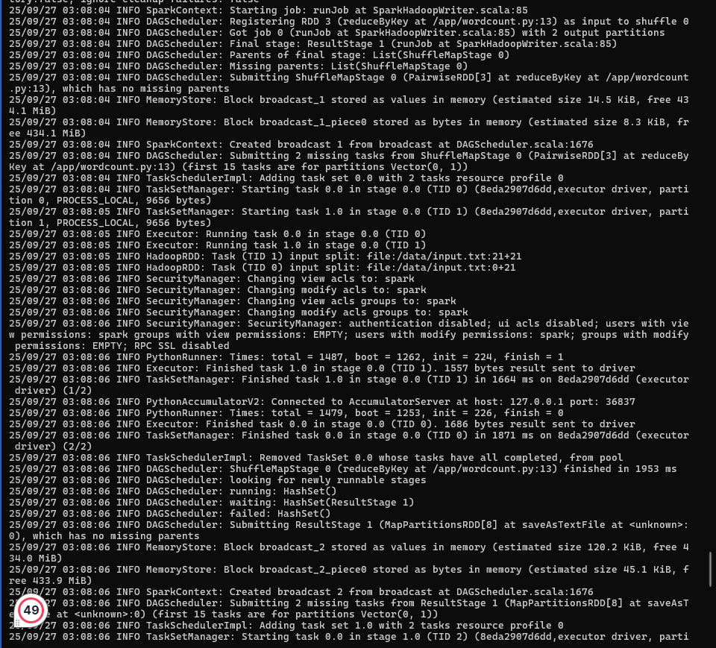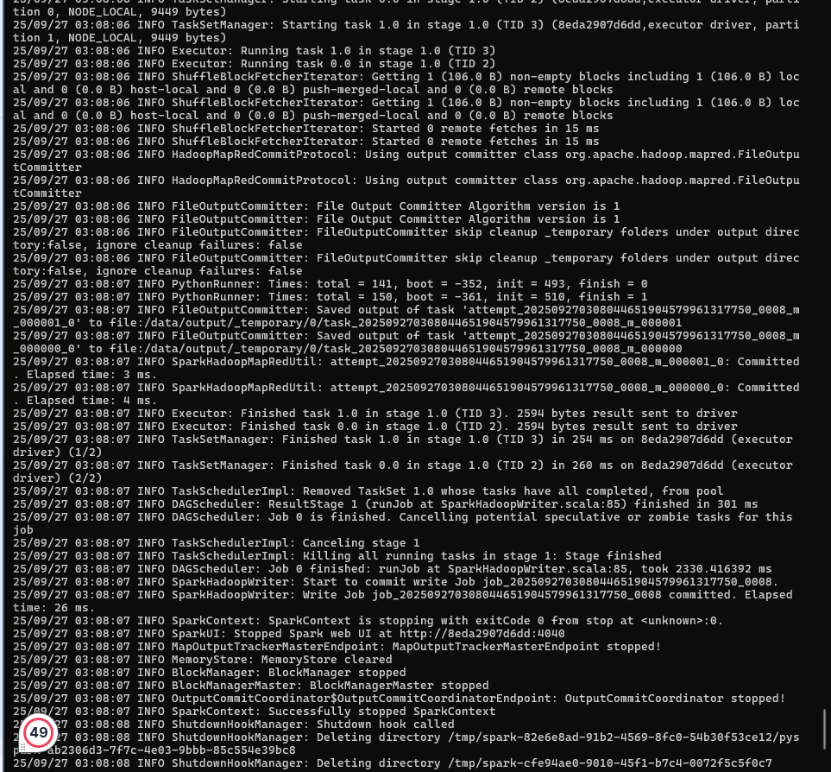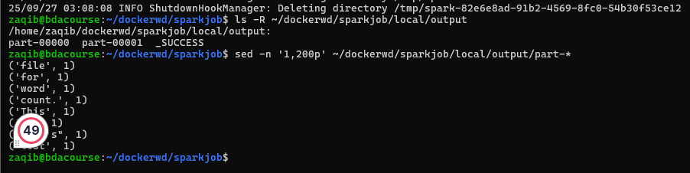

## Multi-Stage Build:



# Stage 1: build

FROM maven:3.6-jdk-11 AS builder

WORKDIR /build

COPY . .

RUN mvn package

# Stage 2: run

FROM openjdk:11-jre-slim

WORKDIR /app

COPY --from=builder /build/target/myapp.jar .

CMD ["java", "-jar", "myapp.jar"]

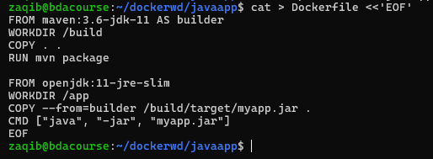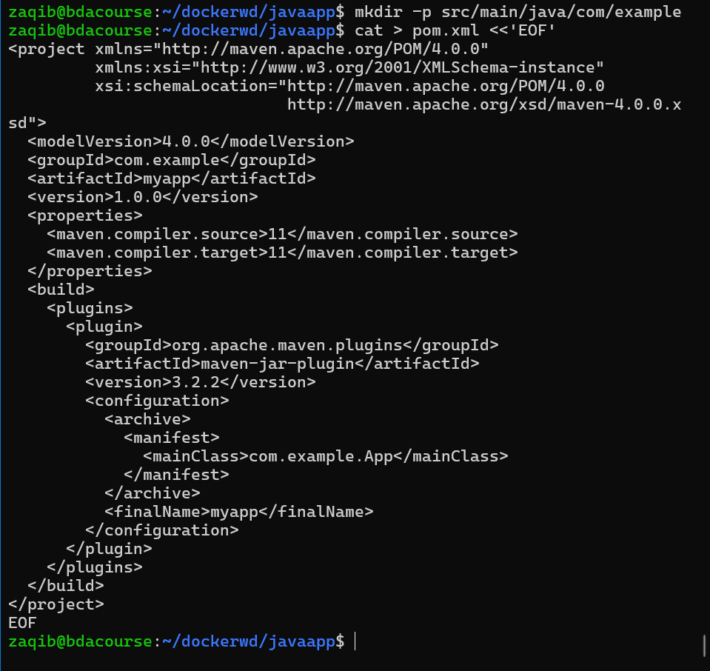

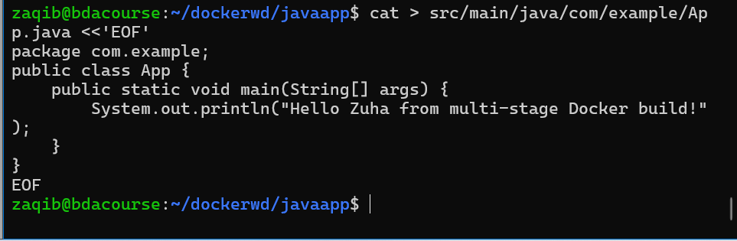

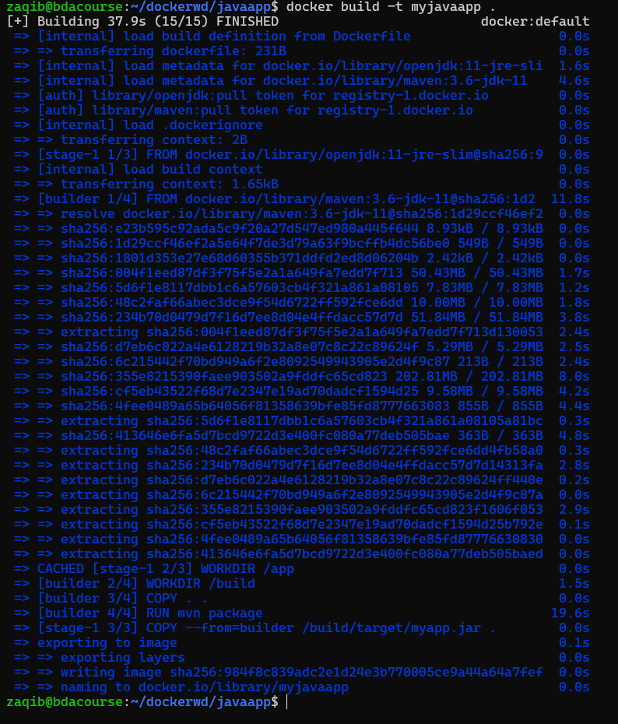

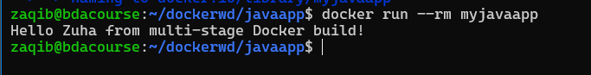

Docker Compose

Docker Compose is a tool to define and run multi-container applications.

Instead of running many docker run commands, you use one YAML file (docker-compose.yml).

With one command (docker-compose up), you can start a whole system (e.g., Spark cluster + Hadoop + Jupyter).



## Workflow:

Write a docker-compose.yml file.

docker-compose up -d

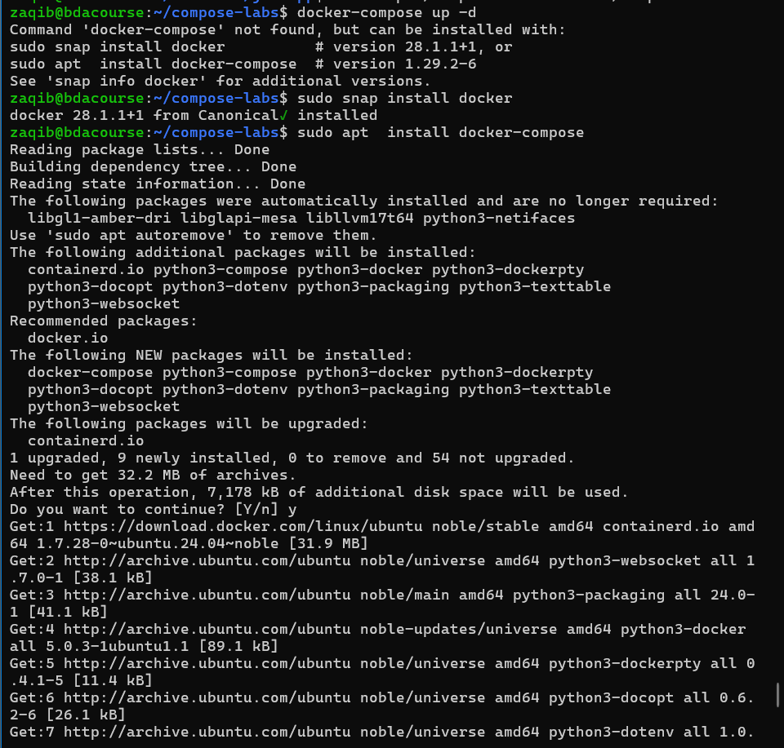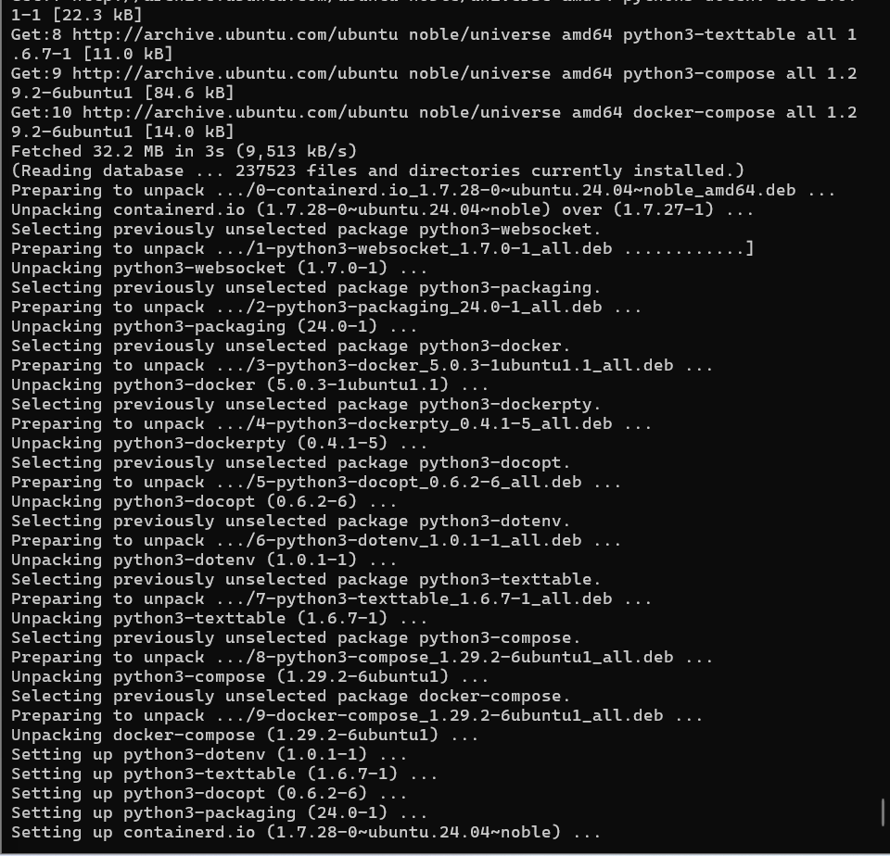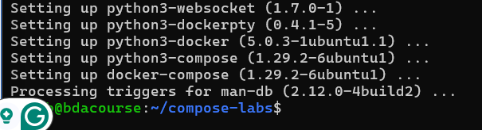

docker-compose down

## Keywords:

| **Keyword** | **Purpose** |
| --- | --- |
| version | Compose file format (3.9 is latest stable). |
| services | Defines containers (each service = one container). |
| image | Use pre-built image. |
| build | Build from a Dockerfile. |
| ports | Expose container ports → "HOST:CONTAINER". |
| volumes | Attach volumes/bind mounts. |
| networks | Put containers on the same network. |
| depends_on | Control startup order. |
| environment | Set environment variables. |
| command | Override default CMD. |
| restart | Restart policy (no, always, on-failure). |
| scale | Run multiple replicas (or use docker-compose up --scale). |

## Anatomy:

version: "3.9" # Docker Compose file format version

services: # Define all containers here

web: # Service name (like container name)

image: nginx:latest # Use an image from Docker Hub

ports:

- "8080:80" # Map host:container port

volumes:

- webdata:/usr/share/nginx/html # Mount volume

networks:

- mynet # Connect to custom network

app:

build: ./app # Build from Dockerfile in ./app

depends_on:

- db # Start db before app

environment:

- DB_HOST=db

- DB_USER=root

networks:

- mynet

db:

image: mysql:8

environment:

MYSQL_ROOT_PASSWORD: root

MYSQL_DATABASE: testdb

volumes:

- dbdata:/var/lib/mysql

networks:

- mynet

volumes: # Declare named volumes

webdata:

dbdata:

networks: # Declare networks

mynet:

## Simple NGINX web server:

version: "3.9"

services:

web:

image: nginx:latest

ports:

- "8080:80"

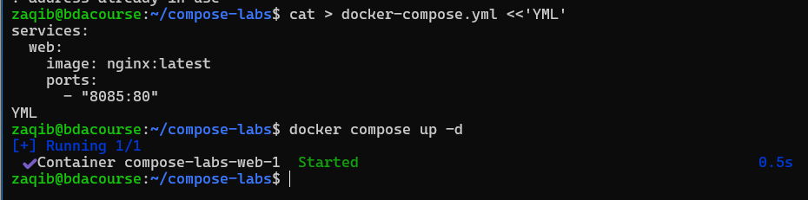

Run: docker-compose up -d

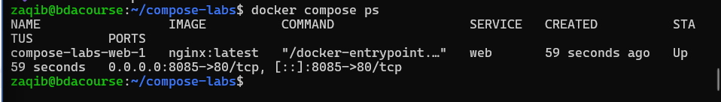

See: <http://localhost:8080>

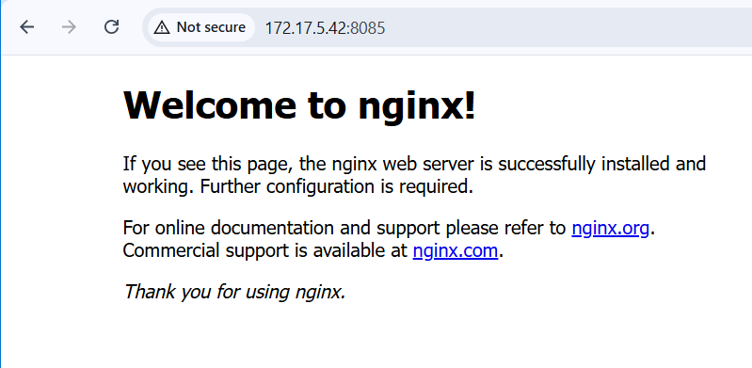

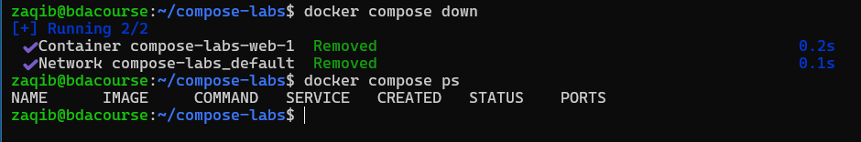

## Web + Database:



version: "3.9"

services:

db:

image: mysql:8

environment:

MYSQL_ROOT_PASSWORD: root

MYSQL_DATABASE: mydb

volumes:

- dbdata:/var/lib/mysql

web:

image: phpmyadmin/phpmyadmin

environment:

PMA_HOST: db

ports:

- "8081:80"

depends_on:

- db

volumes:

dbdata:

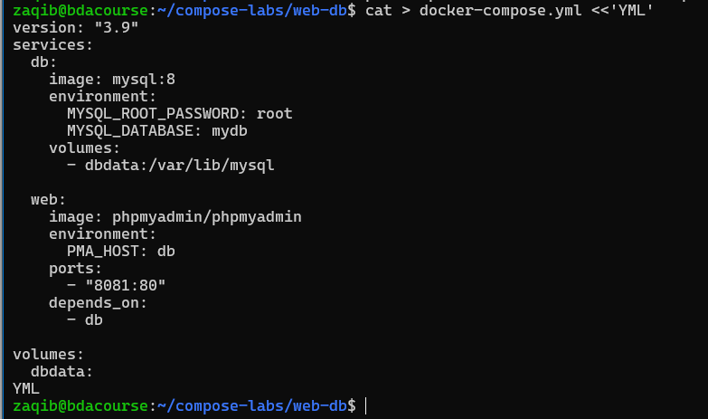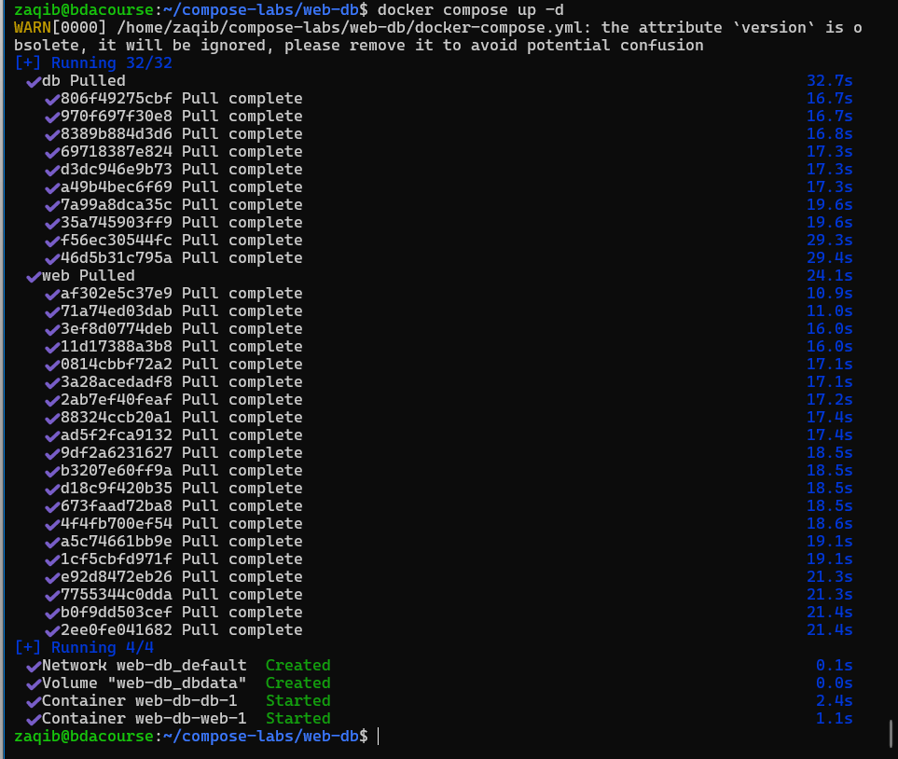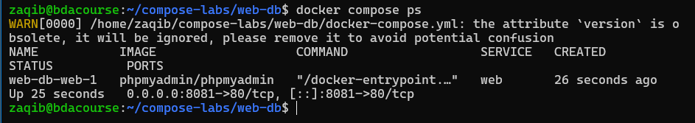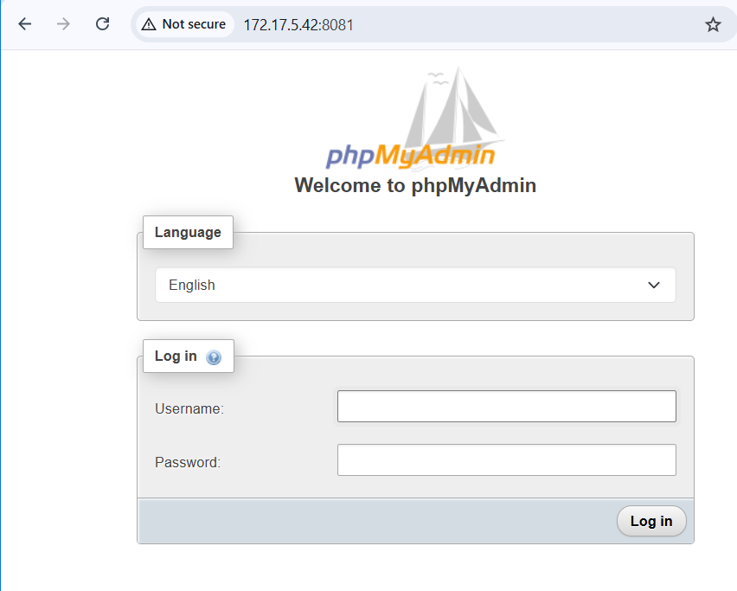username: root, password: root

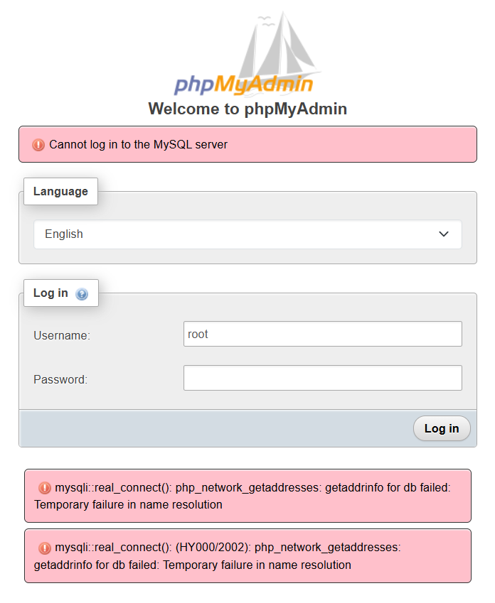

So we see that its running but DB is not connected. Lets see logs:

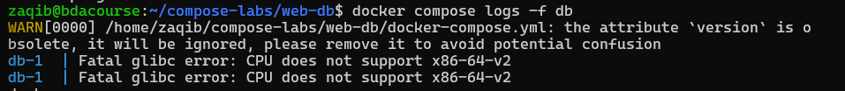

Meaning db has not started. Lets switch DB as its not cpu compatible.

First close the container running

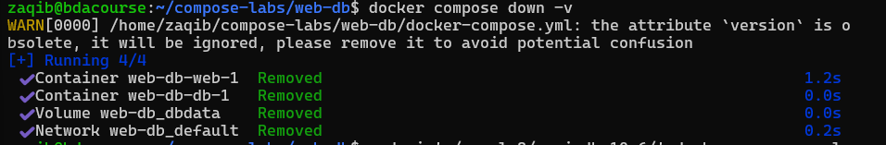

Then lets move to maria db



And stop the version errors



Now lets start

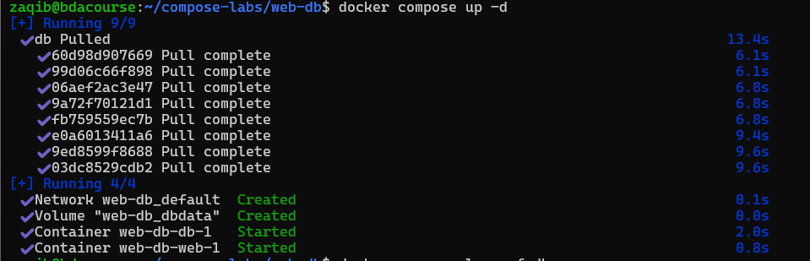

Lets check logs

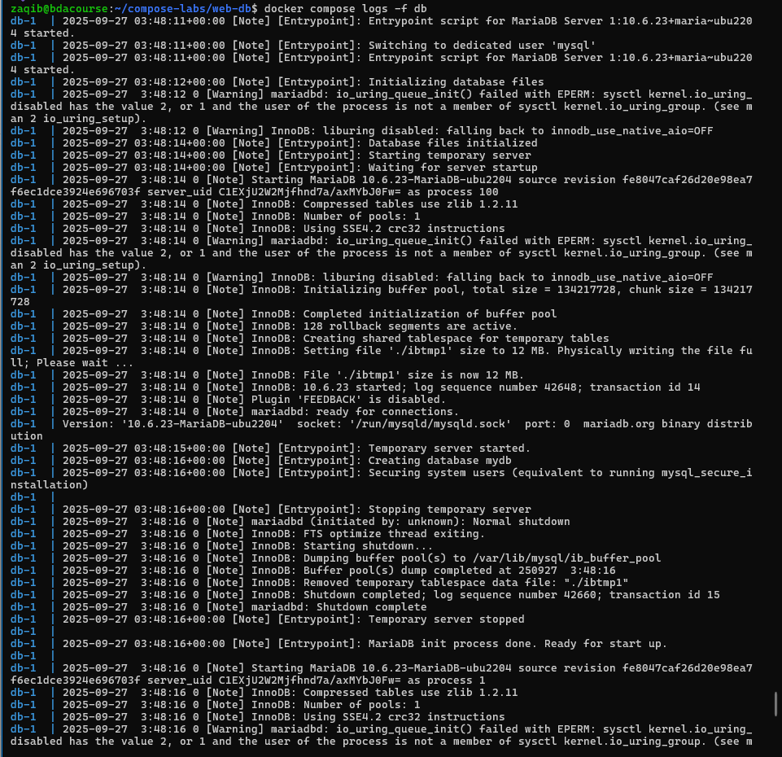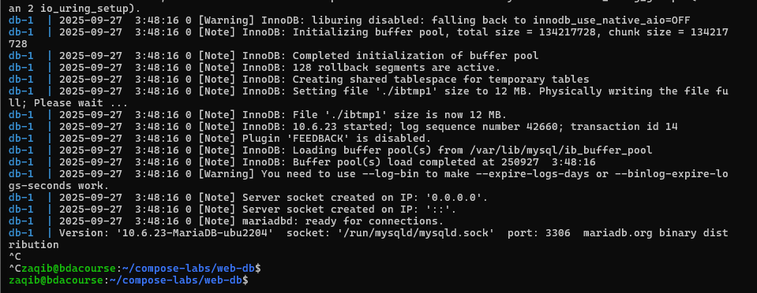

So we see the message “ready for connections”. So lets try logging in via the web browser now:

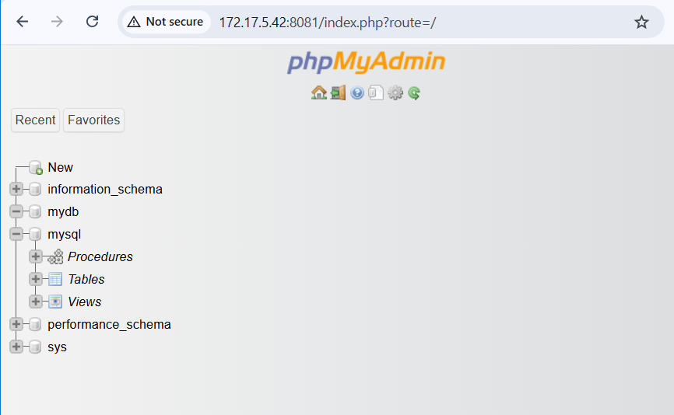done

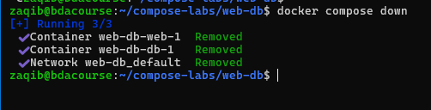

## Python App and Redis:



version: "3.9"

services:

redis:

image: redis:alpine

ports:

- "6379:6379"

app:

build: ./app

command: python app.py

volumes:

- ./app:/usr/src/app

depends_on:

- redis

Now we need a minimal docker file to talk to redis

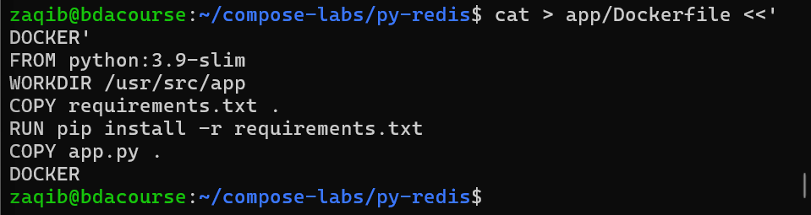

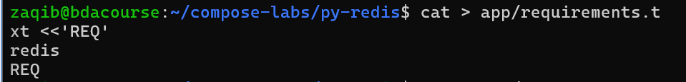

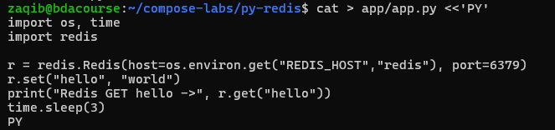

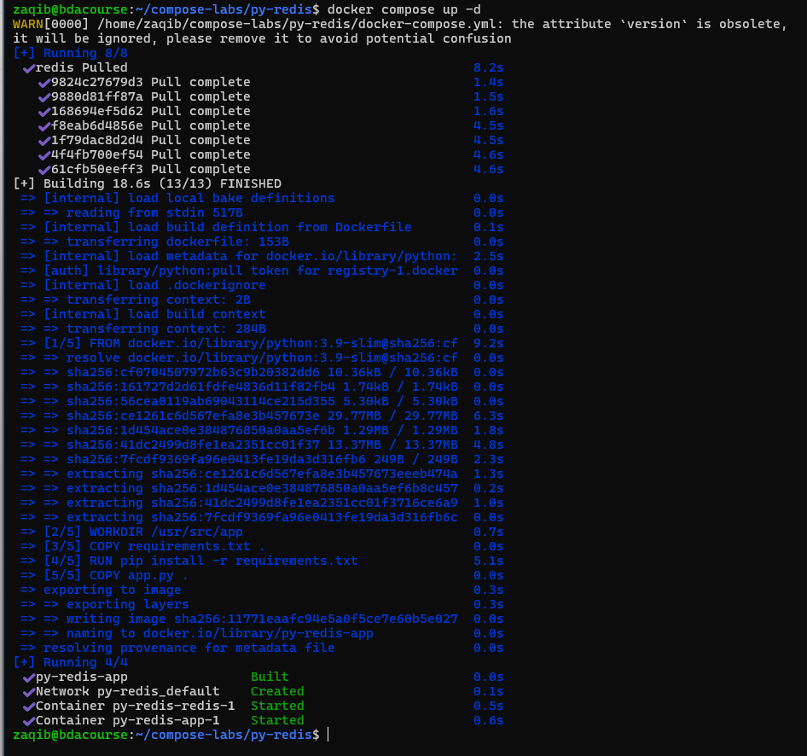

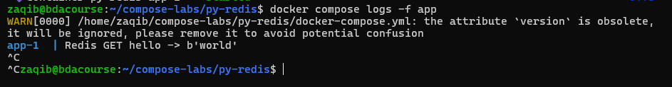

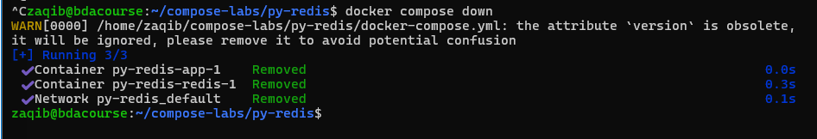

## Spark Cluster (BDA):



version: "3.9"

services:

spark-master:

image: bitnami/spark:latest

environment:

- SPARK_MODE=master

ports:

- "7077:7077"

- "8080:8080"

spark-worker:

image: bitnami/spark:latest

environment:

- SPARK_MODE=worker

- SPARK_MASTER_URL=spark://spark-master:7077

depends_on:

- spark-master

deploy:

replicas: 2

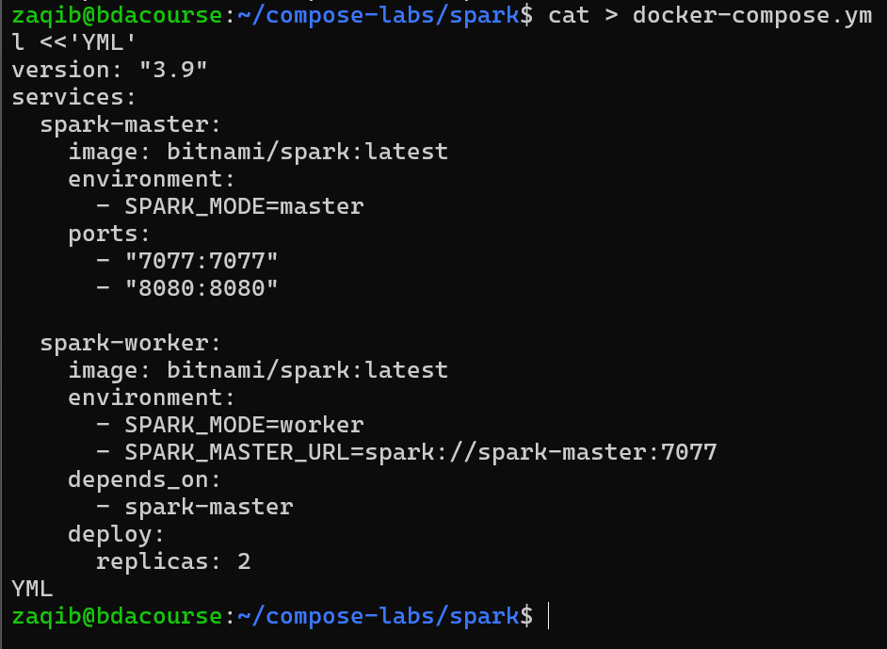

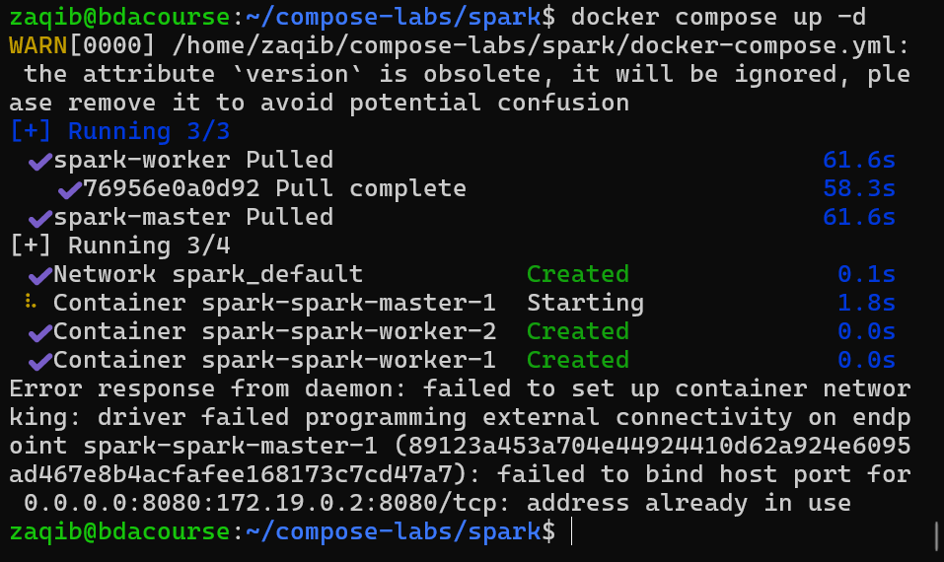

Port is in use. Lets change it

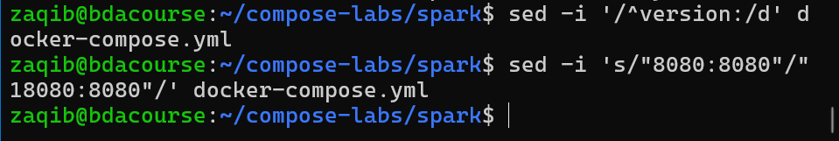

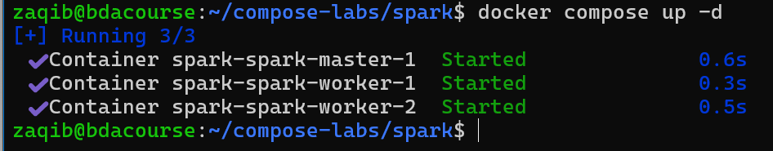



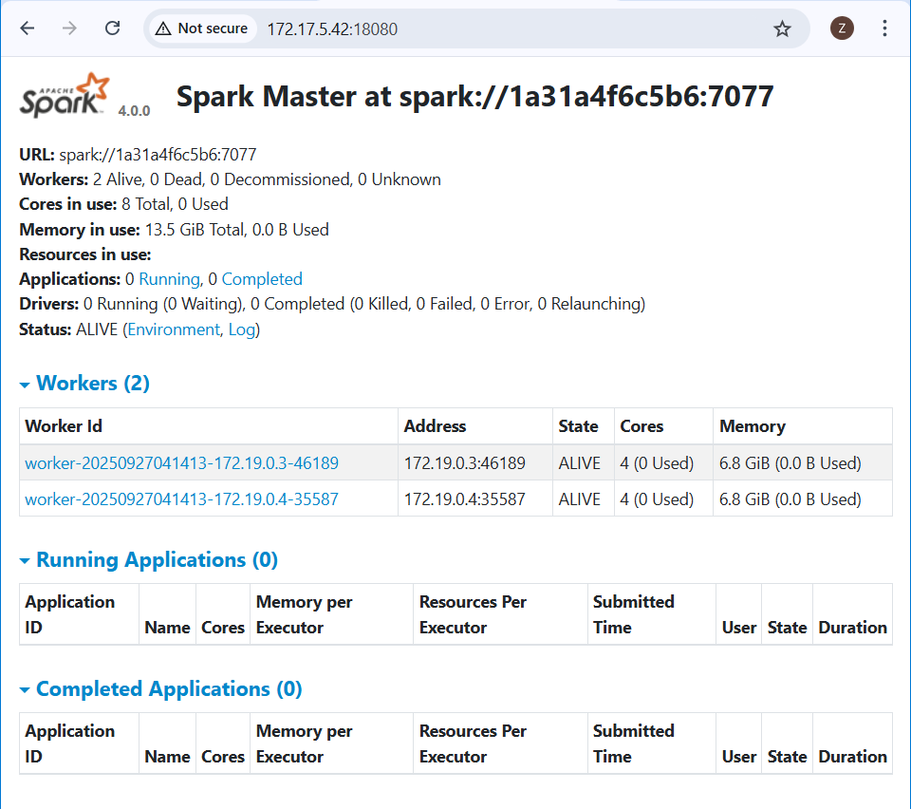

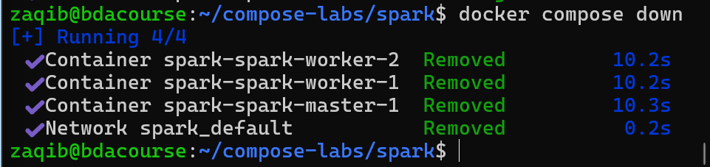

## Hadoop Namenode + Datanode:

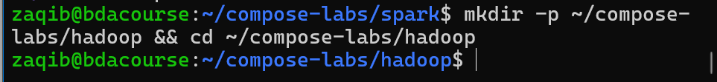

version: "3.9"

services:

namenode:

image: bde2020/hadoop-namenode:2.0.0-hadoop3.2.1-java8

environment:

- CLUSTER_NAME=test

ports:

- "9870:9870"

volumes:

- namenode:/hadoop/dfs/name

datanode:

image: bde2020/hadoop-datanode:2.0.0-hadoop3.2.1-java8

environment:

- CLUSTER_NAME=test

ports:

- "9864:9864"

volumes:

- datanode:/hadoop/dfs/data

depends_on:

- namenode

volumes:

namenode:

datanode:

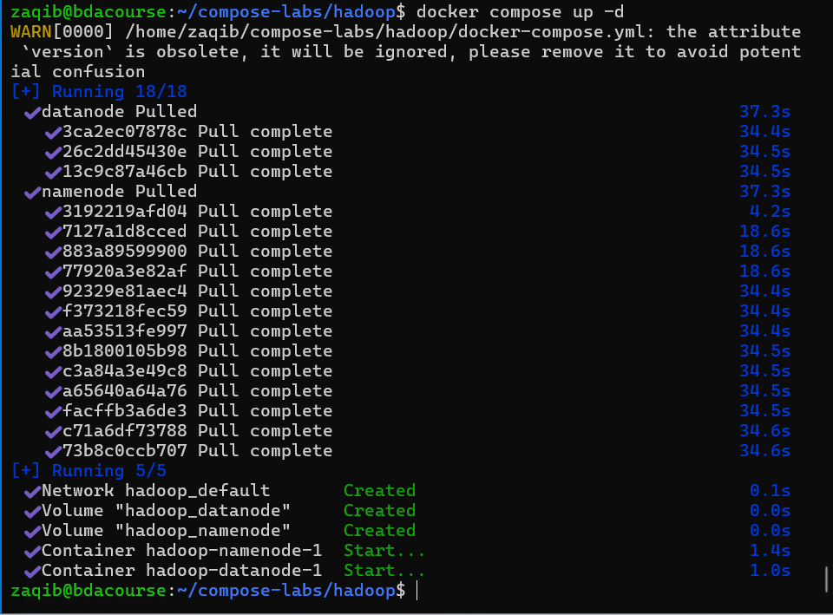



Namenode

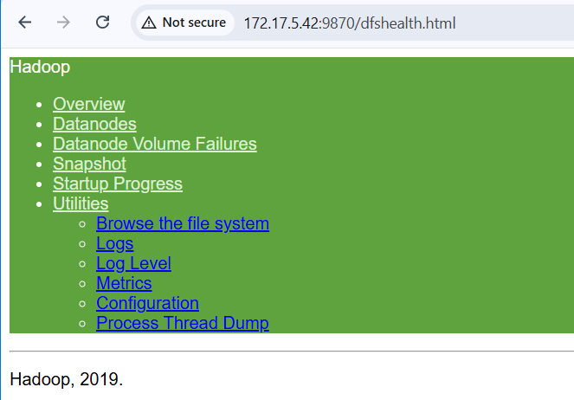

Datanode

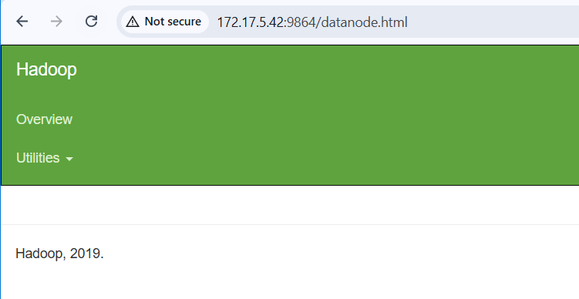

## Useful Commands:

# Start services (detached)

docker-compose up -d

# Stop and remove

docker-compose down

# Rebuild images and restart

docker-compose up --build -d

# View logs

docker-compose logs -f

# List running services

docker-compose ps

# Scale service (e.g., 3 workers)

docker-compose up -d --scale spark-worker=3

Exercise – Combine it all

**Exercise 1: Multi-Service Log Analyzer with Volumes & Compose**

**Statement:** Create a system that ingests log files into a container, stores them in a volume, processes them with a Python app, and makes results accessible via a web dashboard.

Services:

1. Python Log Processor → parses logs and writes summaries.
2. Postgres → stores parsed results.
3. Adminer (web UI for DB) → lets students access and query data.

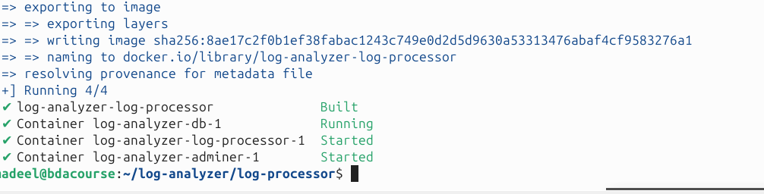

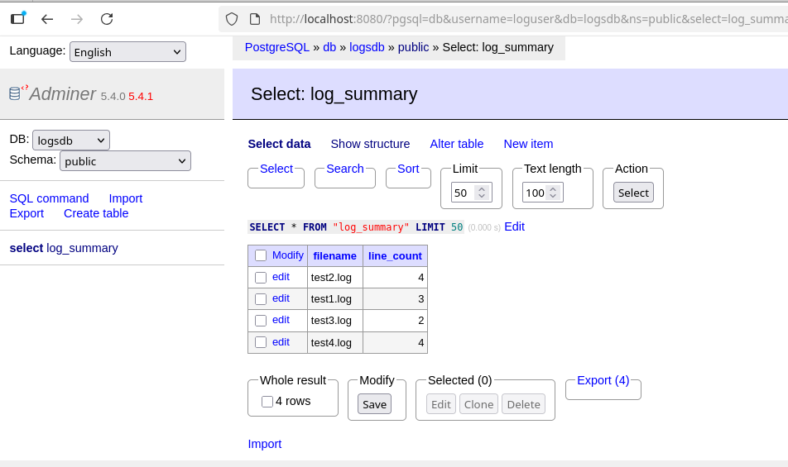

In this exercise, we created a multi-container log analysis system using **Docker Compose**, consisting of a Python log processor, a Postgres database, and Adminer as a web interface. The goal was to take raw log files from our machine, process them in a container, store the results in a database, and view them in a web interface.

The docker-compose.yml file is used to define all three services and their configuration: the **log-processor** service builds from a local Dockerfile, mounts the host logs/ folder as a volume so the container can access log files, and sets environment variables for connecting to the database. The Python processor (processor.py) reads log files from the shared logs/ folder, counts the number of lines in each file, and stores the results in the log_summary table in Postgres. The **db** service uses the official Postgres image, sets the database name, user, and password through environment variables, and stores its data in a named volume (dbdata). The **Adminer** service provides a web UI, and maps container port 8080 to the host.

**Exercise 2: Word Frequency Analyzer with Web UI, Redis, and Background Worker**

Statement: Build a web app where users upload text files through a Flask frontend. Files are stored in a volume, queued in Redis, processed by a worker container, and results (word counts) are stored back into Redis. The web app then displays processed results.

Hints:

* Write a Dockerfile for a custom Flask app.
* Use Redis as a message queue/cache.
* Run multi-container apps with Docker Compose.
* Mount bind mounts and named volumes to manage persistent storage.
* Access and interact with the system from a browser and CLI.

Ok so first lets start by making a clean directory

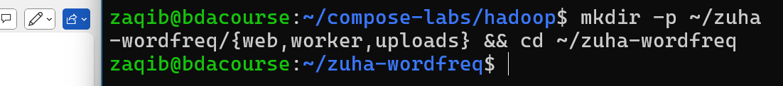

Where:

* web/ -> Flask frontend code + Dockerfile
* worker/ -> background worker code + Dockerfile
* uploads/-> bind-mounted folder shared by web and worker (stores your files)

now lets add the docker file:

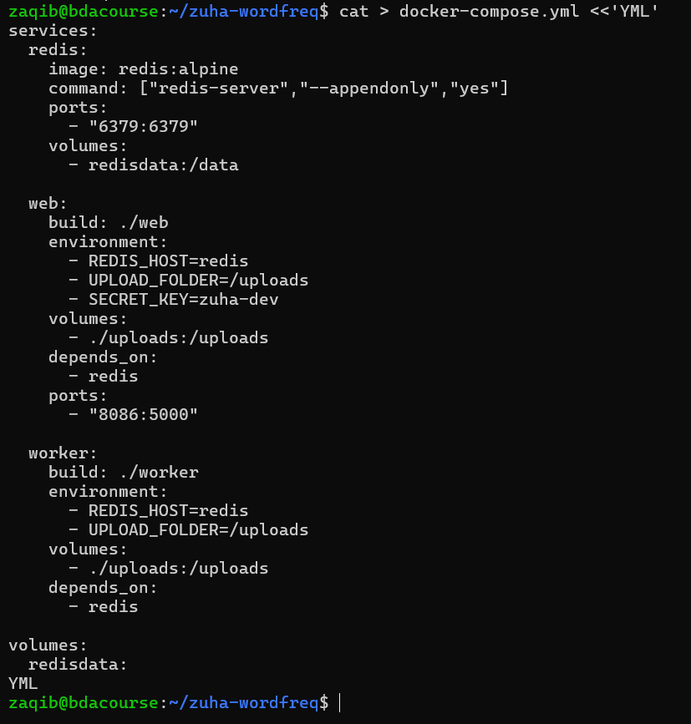

So we basically define 3 services: REDIS which is a queue/cache with a named volume called redisdata. WEB which is our flask app and WORKER the background processor

Both web and worker use the same folder of uploads so they can see the same files.

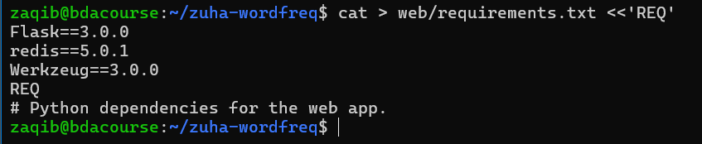

Install the dependencies

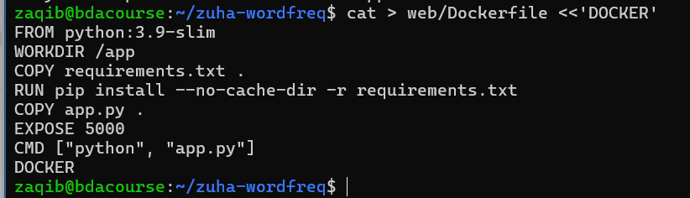

Now lets make app.py

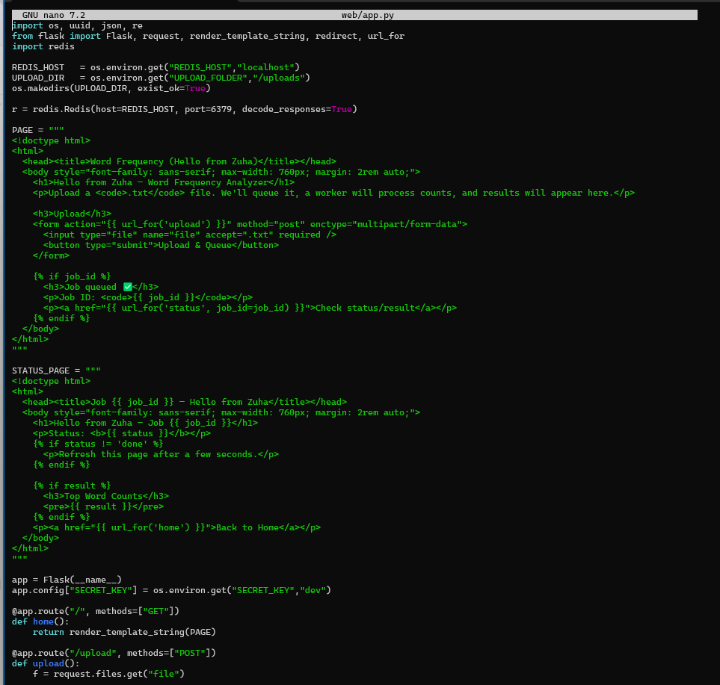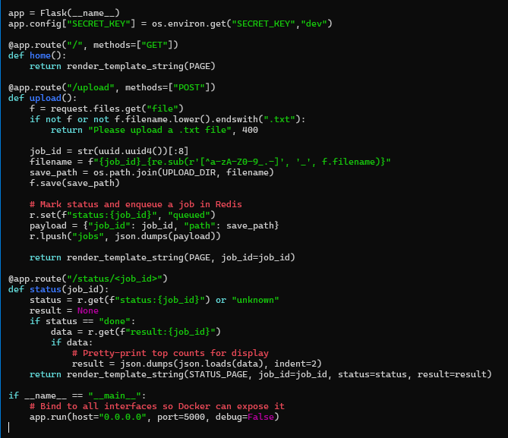

# Web routes:

# - GET / : upload form (shows "Hello from Zuha")

# - POST /upload : saves file to /uploads, enqueues a job in Redis, shows job id

# - GET /status/<job_id>: shows status; when done, shows top word counts

Now worker requirements, docker file

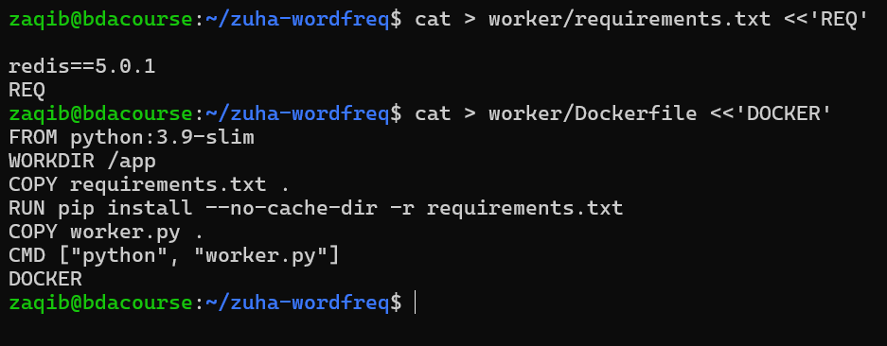

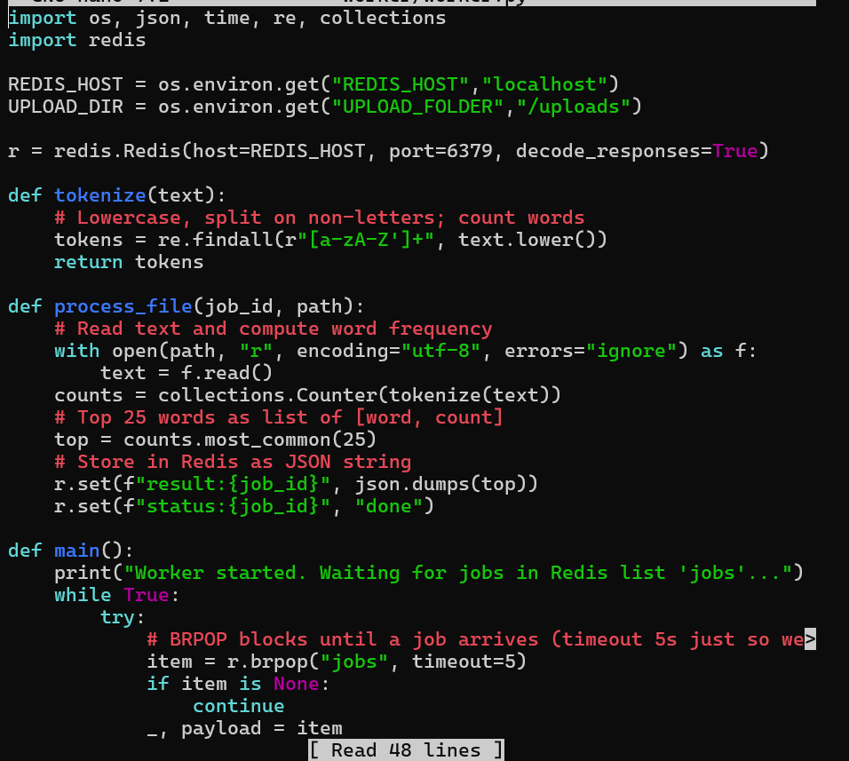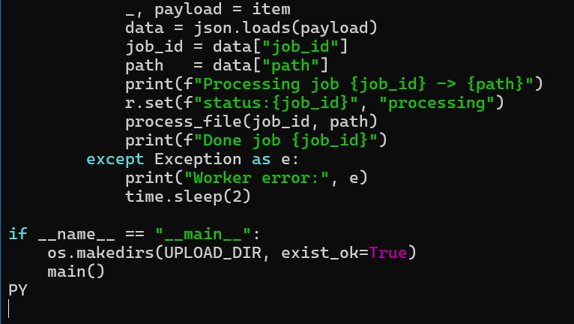The worker blocks on Redis list "jobs", processes files from /uploads, and writes results to keys: status:<job_id> and result:<job_id>.

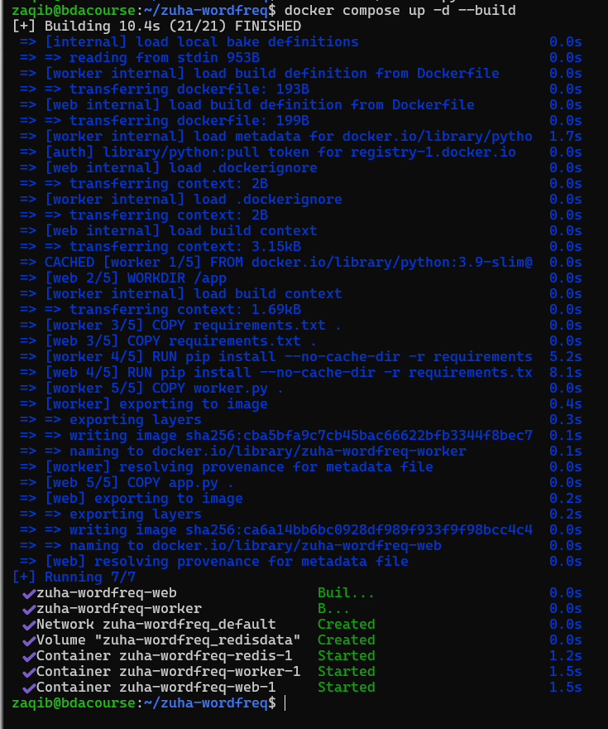

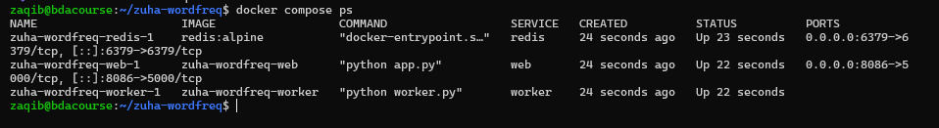

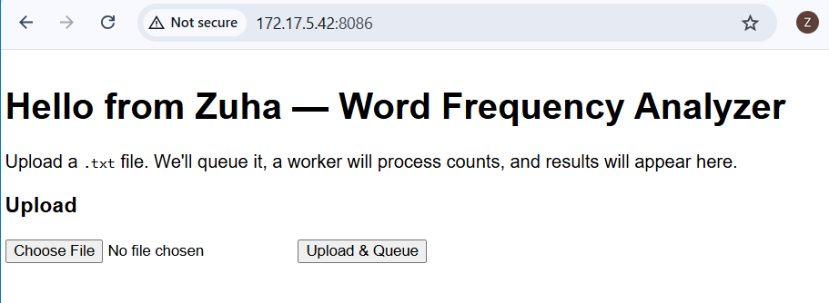

We have chosen the file:

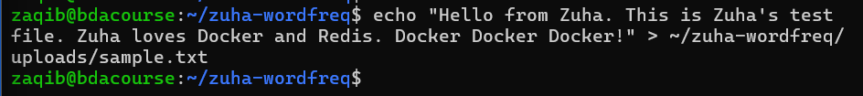

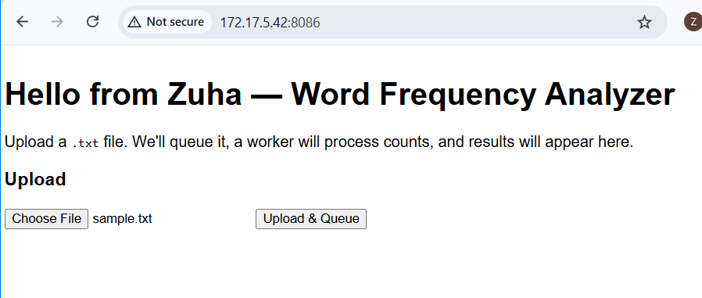

Press upload and queue

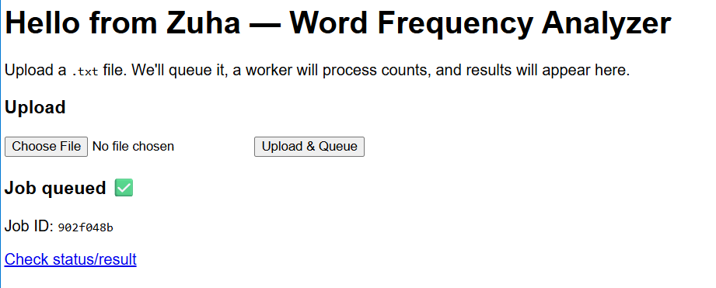

Click check status

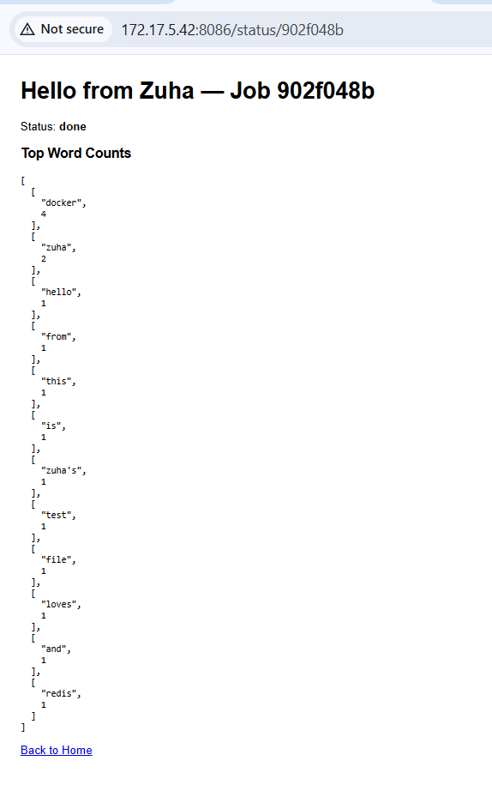

In cli as well

